Course 6 Creative Designing in Power BI

Module 1 Visualization and design

Visually Cohesive Design
Color theory is indeed a crucial aspect of designing effective reports and dashboards, just like choosing the right outfit for the right occasion. In both cases, the goal is to achieve a harmonious and visually appealing outcome. Let's break down the key points from your text to understand how color theory can enhance your Power BI reports and presentations at Adventure Works:
1. The Color Wheel
- Primary Colors: Red, blue, and yellow.
- Secondary Colors: Created by mixing primary colors (e.g., green, orange, purple).
- Tertiary Colors: Mixes of primary and secondary colors (e.g., red-orange, blue-green).
- Understanding the relationships between these colors helps in picking combinations that work well together in a dashboard.
2. Color Harmony
- Complementary Colors: Opposites on the color wheel (e.g., red and green). Using them creates contrast and energy.

- Analogous Colors: Colors next to each other (e.g., blue, green, and yellow) for a calm and cohesive design.
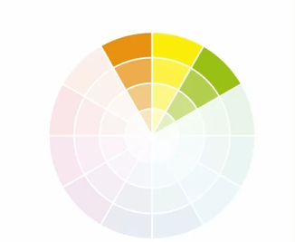
- Triadic Colors: Equally spaced around the wheel (e.g., red, yellow, and blue) to create vibrant and balanced designs.
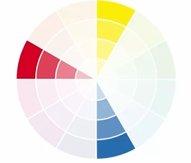
- Monochromatic Colors: Variations of the same hue (different shades of blue, for example), providing a more subtle and professional look.


3. Psychology of Color
- Emotional Impact: Colors evoke emotions. For example, orange and yellow can evoke feelings of excitement, which may work well for showcasing new products in your Adventure Works presentations.
- Cultural Differences: Be mindful of cultural interpretations. In a global company like Adventure Works, a color like red may convey luck in Asian markets but signal danger in Western contexts.
4. Accessibility
- Consider people with color blindness, especially red-green color blindness. Using high contrast combinations and providing alternative markers such as symbols, patterns, or labels ensures that all users can interpret the visuals correctly.
5. Applications in Power BI
- When creating Power BI reports for Adventure Works, understanding how to mix and match colors helps to make your data visuals not only visually engaging but also more readable and accessible to different audiences. For instance:
  - Use complementary colors to highlight contrasting data points.
  - Apply monochromatic schemes for more formal reports like sales summaries.
  - Incorporate high contrast schemes when visual clarity and accessibility are key, especially in reports that will be shared globally or with stakeholders who might have visual impairments.

Your description emphasizes the importance of color in report and dashboard design, particularly in business intelligence tools like Power BI. Let's break down the key takeaways and how they can be applied in your work at Adventure Works:
1. Color as a Communication Tool
- Psychological Impact: Colors like red, orange, and yellow evoke associations such as heat, urgency, and excitement, which can be useful for guiding viewer focus.
- Symbolism in Business Contexts: Red can symbolize negative values like losses, while green typically represents positive outcomes or profits. These color cues help your audience quickly grasp important data points without needing to analyze in detail.
2. Roles of Colors in Dashboard Design
- Background Colors: Low saturation backgrounds help avoid distractions, allowing viewers to focus on the key insights. For example, using a light grey or soft pastel background in your reports can create a subtle backdrop that makes the data stand out.

- Dominant Color: Your primary color should create contrast and set the tone for the entire report. For Adventure Works reports, you might choose a brand-specific dominant color to maintain corporate identity.
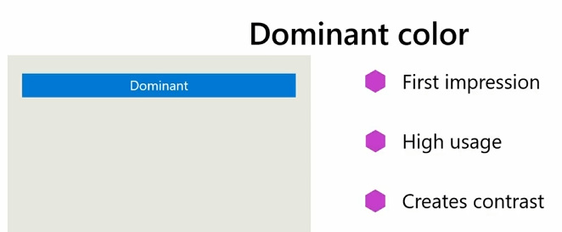
- Accent Colors: Use accent colors to highlight critical data points like warnings or action buttons. For instance, you can use a bright orange for a call-to-action like “Check Profits” or red to signal negative trends.
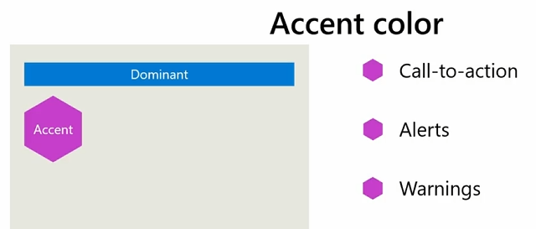
- Semantic Colors: These are particularly useful for quick comprehension—such as green for “good” performance and red for “poor” performance in conditional formatting.
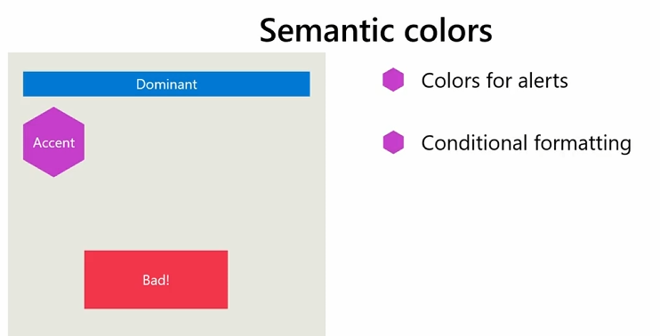
3. Practical Application in Power BI
- Conditional Formatting: In your example, using green for positive profit margins and red for negative ones allows executives to quickly spot trends in profit performance. Power BI’s conditional formatting rules make it easy to apply this visual distinction automatically.
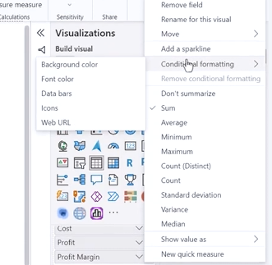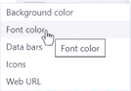
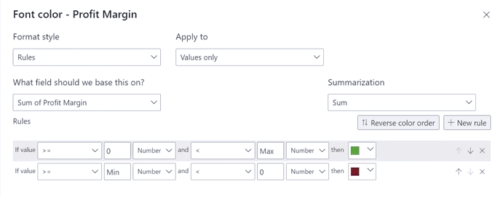
- Column Chart Colors: By assigning colors like green to the years 2020 and 2021 (profitable years) and red to 2022 (a loss year), the dashboard visually conveys profit trends across the years without needing the user to read numbers.
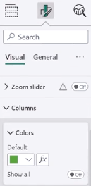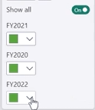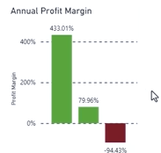
- Color Themes for Accessibility: Selecting an accessible theme, like the Accessible City Park, ensures that your reports meet color contrast requirements and are readable for a wide audience, including those with color vision deficiencies.
4. Creating a Consistent Color Palette
- Using a color palette in Power BI via a JSON file allows you to standardize colors across all reports. This means that your visualizations will remain consistent, following the same theme, helping executives and stakeholders recognize key data patterns easily.

5. Enhancing Report Accessibility
- Maximizing Visibility: By increasing the font size and using high-contrast color schemes, you ensure that all viewers, including those with visual impairments, can easily interact with your reports.
- Red-Green Color Blindness: It's critical to avoid relying solely on red-green contrasts, as those with red-green color blindness might find it difficult to differentiate. Consider using different hues or patterns to help visually impaired users interpret data effectively.

Positioning and scaling
are crucial in report and dashboard design, especially for creating clear, intuitive, and visually appealing Power BI reports. Let’s break down how you can apply these principles effectively, particularly for your work at Adventure Works:

1. Positioning
- Guiding Attention: Positioning the most critical information at the top of the report helps direct the viewer’s focus. For example, if you’re presenting Adventure Works' annual revenue growth, place the key revenue metrics front and center, so stakeholders get the essential figures at first glance.
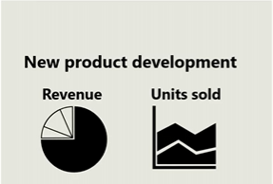
- Logical Flow: Organize the information to guide viewers through the report naturally. Start with high-level insights (e.g., total revenue, revenue by region), then flow into more detailed data (e.g., specific product line performance). This helps the audience understand the big picture first, then dive deeper into supporting details.

- Contextual Visuals: Pair related visualizations together, like a bar chart of regional revenue alongside a map of revenue distribution, allowing users to make connections between geographical locations and their revenue performance. This layout aids in quick decision-making.

2. Scaling
- Emphasizing Key Information: Use larger fonts and bold text for headlines or titles that introduce important metrics (e.g., "Revenue Growth by Region"). By scaling the titles larger than the rest of the text, the viewer knows immediately where to focus.
- Proportionate Scaling: Ensure that visual elements like charts, graphs, and data labels are scaled to maintain readability but not overwhelm the viewer. For instance, titles should be larger, while legends and axis labels can be smaller but still readable. This creates a hierarchy of information, guiding the viewer to the most critical parts first.
- Consistent Scaling: When using multiple charts in a report, ensure the axes are consistent (e.g., all charts with the same sales metric should use the same scale). This allows users to easily compare data across different regions or time periods without having to recalibrate their understanding of the numbers.
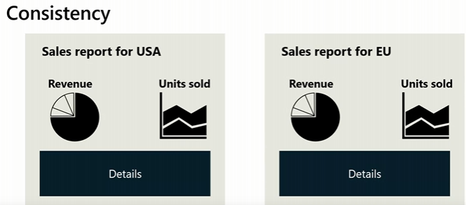

3. Best Practices for Reports
- Central Placement for Key Data: Place your most important visuals, such as revenue by region bar charts, in a central position where they will naturally draw attention. Other supporting visuals, like trend lines or additional details, can be placed around this core visual, providing context without distracting from the key message.
- Space Management: Avoid overcrowding your report with too many visual elements. Use white space strategically to separate different sections, helping the viewer focus on one piece of information at a time.

4. Practical Application in Power BI
- For Adventure Works' Annual Report: If you are showcasing annual revenue growth by region, here’s how you could apply positioning and scaling:
  - Place the bar chart showing revenue figures for each region in a prominent spot.
  - Include a map next to the chart to visually correlate regions with their revenue growth.
  - Use conditional formatting on the bar chart to emphasize regions with the highest or lowest growth.
  - Scale the chart titles larger and bold, while keeping data labels and legends smaller but still clear.

5. Creating a Balanced User Experience
- Consider Navigation: Imagine how an executive or marketing director (like Renee from Adventure Works) would navigate the report. They are looking for quick, high-impact insights. So, guide them through with smart positioning and a scaled hierarchy of data. Start with revenue performance, then move to detailed metrics like profit margins, regional breakdowns, or marketing campaign impacts.
- Visual Flow: Ensure that the report follows a logical sequence from top to bottom or left to right, much like reading a document, so users don’t get lost or overwhelmed by scattered data points.

To redesign the salesperson performance report in Power BI and improve its layout, follow these steps:
1. Apply Accessibility Theme
- Navigate to the View tab, choose the Accessibility City Park theme from the drop-down. This ensures good color contrast for legibility.
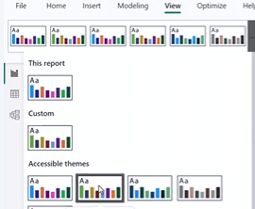
2. Increase Font Size and Improve Contrast
- Change the font size and color to ensure better visibility.
- Customize the theme by navigating to View > Themes > Customize Current Theme > Advanced. Set the second-level elements (like axis titles and labels) to black for consistency.
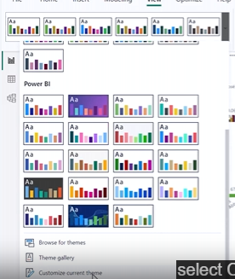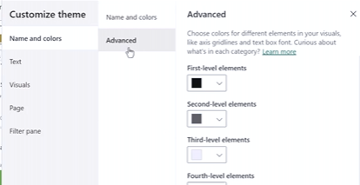
3. Simplify the Total Sales by Year and Salesperson Chart
- Select the column chart and remove the Salesperson field from the Legend to reduce clutter.
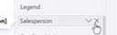
- Add a Salesperson Slicer to provide better interactivity, enabling users to filter sales data by salesperson.
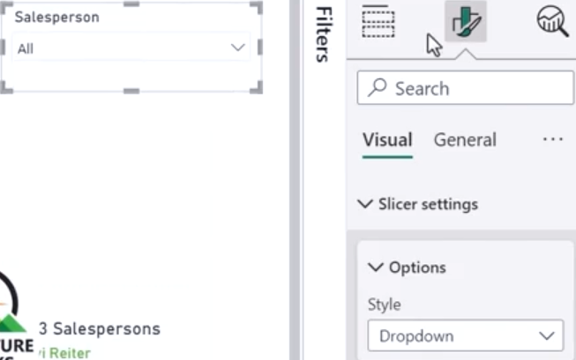
- Resize and move the chart to the left side of the canvas.
- Turn off the X-Axis Title for simplicity.
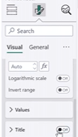
- Apply Conditional Formatting to the chart columns based on the total sales values using shades of black and green. Remove the color legend to keep it clean.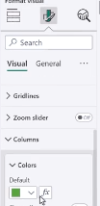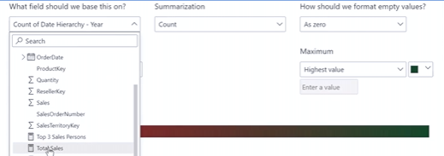
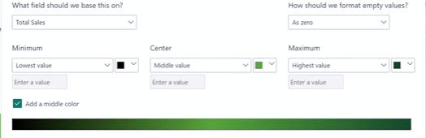
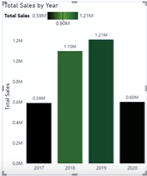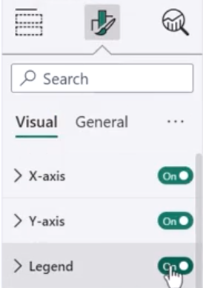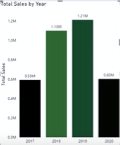
- Set the text size for the X and Y axes and data labels to 12 points.

4. Adjust the Quantity Sold by Salesperson Chart
- Replace the Salesperson field with the Year field on the X-axis to align with the slicer.
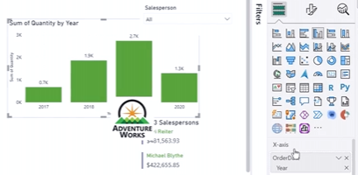
- Rename the chart to "Quantities Sold" and adjust axis labels.
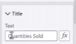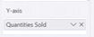
- Apply the same Conditional Formatting and remove the color legend for consistency.
- Resize and align this chart parallel to the Total Sales chart.
5. Top Three Salespersons Card
- Resize the card visual and place it below the slicer.
- Change the text size to 18 points and the color to black for better visibility and accessibility.
6. Logo and Report Title
- Position the Adventure Works logo in the top-left corner.
- Add a report title, such as “Salesperson Performance,” at the top of the canvas for clarity.
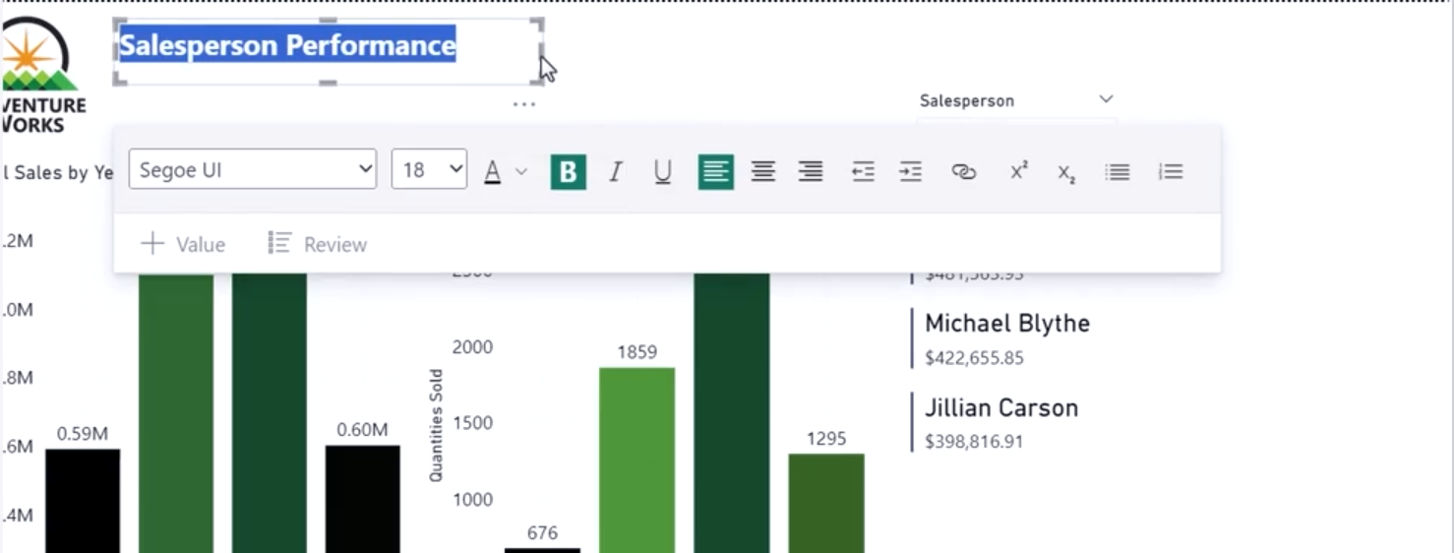
7. Final Touches
- Review the layout, ensuring that visuals are well-positioned and aligned for easy comprehension.
- Ensure all text, axes, and labels have consistent formatting and legibility.

Chaotic and Cohesive pages
In your journey to improve report design, focusing on the balance between chaos and cohesion is crucial. Here are some actionable steps to achieve a cohesive design:
1. Utilize a Consistent Color Scheme
- Align your color palette with the AdventureWorks brand identity. This consistency reinforces visual harmony across your charts, graphs, and other visuals.
- Highlight key information using accent colors to draw attention, without overwhelming the viewer with too many color variations.
2. Strategic Positioning of Elements
- Group related information together in a logical sequence to enhance readability.
- Avoid overlapping or cluttered visuals by using proper alignment, which can be achieved through grids and guides.
3. Create a Clear Visual Hierarchy
- Use font sizes, bolding, and color to differentiate between headings, subheadings, and body text.
- Ensure the most important information stands out visually, guiding the viewer’s eye naturally through the report.
4. Leverage White Space
- Avoid clutter by leaving ample white space around text and visuals. This allows your audience to absorb information without feeling overwhelmed.
5. Consistency in Typography
- Stick to one or two fonts, ensuring legibility and consistency. This adds to the report’s cohesiveness while maintaining professionalism.
6. Review and Iterate
- Regularly review your design for opportunities to refine and improve. Gather feedback from colleagues or stakeholders and implement changes to ensure your reports are both visually appealing and informative.

Steps for Redesigning a Cohesive Power BI Report:
- Apply an Accessible Theme:
  - Activated the "City Park" theme to ensure color contrast and accessibility.
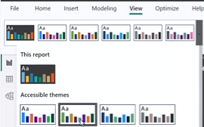
  - Customized the theme to improve label visibility and increase font sizes for clarity.
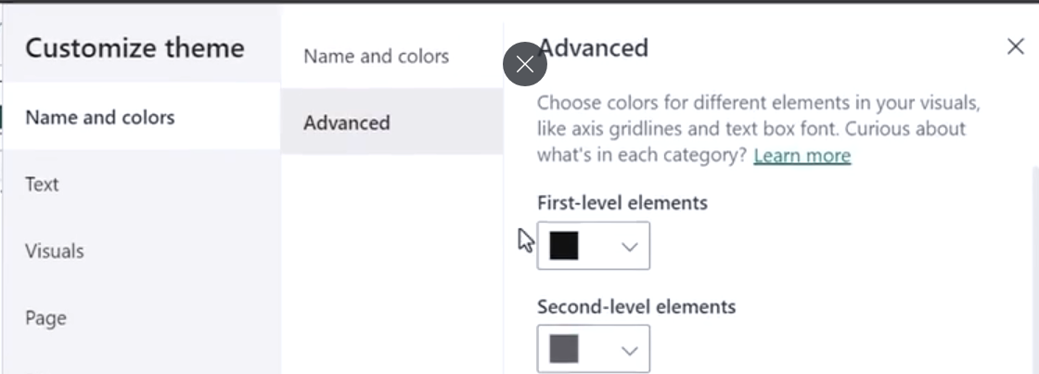
- Position Key Elements:
  - Moved the company logo to the top left and aligned the report title accordingly.
  - Positioned critical visuals (cards for revenue and units sold) together at the top right, making it clear that they are related and of equal importance
.
- Reformat Card Visuals:
  - Updated card visuals for "Revenue" and "Units Sold" by renaming them, adjusting background colors, and increasing text size for emphasis.
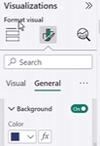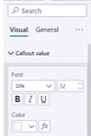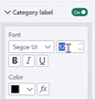
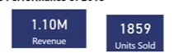
  - Applied consistent formatting across both cards to make them visually cohesive.

- Optimize Line Charts:
  - Renamed line chart titles to more meaningful descriptions, such as "Revenue by Month" and "Revenue by Country."
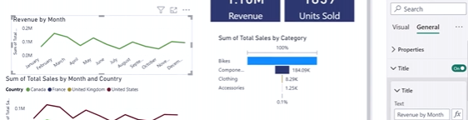
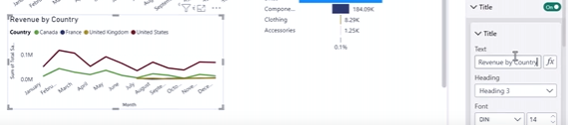

  - Removed redundant elements (e.g., X-axis titles), renamed Y-axis labels to clarify currency, and standardized the gridline styles for clarity.
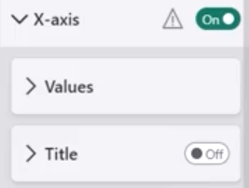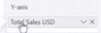
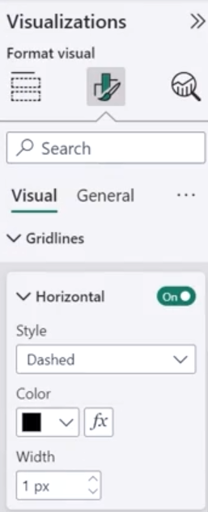
  - Adjusted legends for simplicity and consistency, removing unnecessary legend titles.
  - 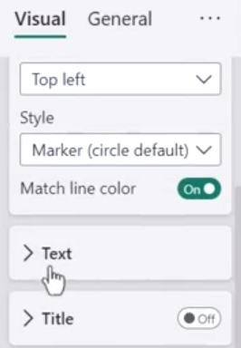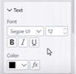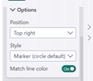
- Enhance Funnel Chart:
  - Updated the funnel chart title to "Revenue by Category."
  - Applied conditional formatting to visually represent sales with a gradient of blue colors, making higher values more distinguishable.
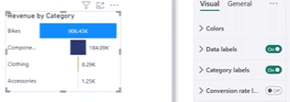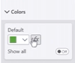
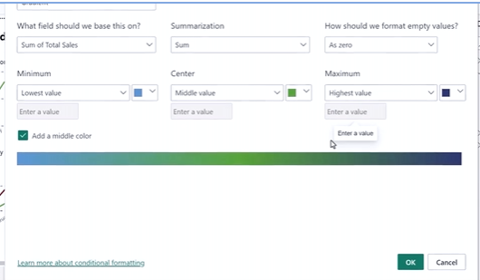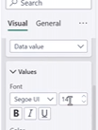
- Final Adjustments:
  - Increased the font size of the titles for accessibility and visual impact.
  - Ensured that visuals were scaled and positioned with equal spacing for a clean, professional look.
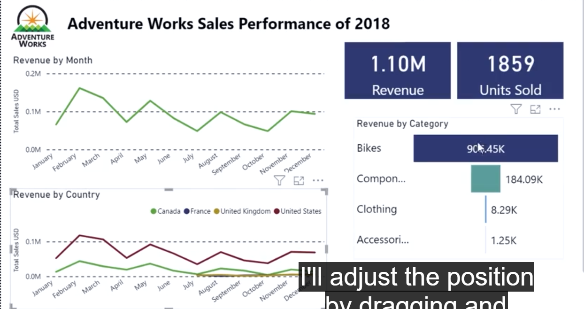
- Which Microsoft Power BI menu item is used to set text, color, and style for a visual element?
The correct answer is: Format Visual
In Power BI, the "Format Visual" menu is where you can customize the appearance of visual elements, including text, color, and style.
- What term describes that the information is grouped together logically and presented in a sequential manner?
The correct answer is: Strategic positioning
Ensure that related information is grouped together logically and presented in a sequential manner. Use alignment and spacing techniques to create a sense of order and structure.
- True or False: Color harmony is a circular diagram that organizes colors based on their relationship to one another, providing insights into color harmonies and combinations in design. It consists of primary colors, secondary colors, and intermediate colors formed by mixing primary and secondary colors.
False
This statement is false. The description given is actually for a color wheel, not color harmony. Color harmony refers to the theory of combining colors in a pleasing arrangement, while a color wheel is the tool used to visualize these relationships.
- You are working on a data analysis project for Adventure Works. The company provides you with a large dataset containing information about the marketing budget of the previous and current quarter. Your task is to create reports that show a detailed list of the quarterly budgets and display the budgets per category in a pie chart. Your objective is to enhance the color scheme, positioning, scale, and overall cohesiveness of the report. In this scenario, how can you simplify the layout? Select all that apply.
The correct answers are: Leave an empty space between the vertical and horizontal visuals to make the elements more readable. Align visual elements vertically and horizontally.
Both of these options would help simplify the layout and improve readability.
Leaving empty space (also known as white space) helps separate elements and reduce clutter.
Aligning elements creates a more organized, cohesive look.
The third option about setting specific titles doesn't necessarily simplify the layout, so it's not a correct answer for this question.
- Which statement best describes the difference between chaotic and cohesive pages in report design?
The correct answer is: Chaotic pages have a cluttered layout with inconsistent use of colors and fonts, while cohesive pages have a clean and organized layout with consistent design elements.
This accurately describes the difference between chaotic and cohesive design. Cohesive design aims for consistency and organization, while chaotic design lacks these qualities.

Considering the audience
In your explanation, you’ve made an excellent point about how critical it is to tailor data presentations to the specific needs of the target audience, just as you would plan different musical performances for distinct groups. Here's a summary of how this concept applies to presenting data effectively:

Key Steps to Tailoring Data Presentations for the Audience:
- Understand the Audience's Characteristics:
  - Roles and Functions: Know who your audience is. For example, executives need high-level KPIs, while analysts prefer detailed breakdowns.
  - Technical Expertise: Gauge their familiarity with the data or software. Are they experts, intermediate users, or beginners?
  - Goals and Objectives: Understand what specific information the audience is seeking (e.g., financial performance for executives vs. customer analytics for marketers).
  - Information Needs: Identify the most relevant data for the audience's decision-making process. For example, marketing teams need campaign data, while finance teams focus on profitability.
- Customize the Format:
  - Preferred Communication Style: Some audiences respond better to visual charts and graphs, while others may prefer detailed textual reports or interactive dashboards.
  - Cultural and Demographic Factors: Consider factors like language and cultural preferences, ensuring accessibility for a broad audience.
  - Time Constraints: Tailor the level of detail to the time the audience has available. Busy executives need concise summaries, while others may want in-depth reports.
- Simplify and Clarify:
  - Simplifying Complex Concepts: Avoid jargon or technical terms when presenting to non-technical audiences, using clear, concise language instead.
  - Highlighting Relevant Insights: Focus on the insights that matter most to the audience. For executives, this might be strategic metrics like revenue or market share, while marketers may care more about customer behavior and campaign performance.
- Use Real-World Scenarios:
  - Contextual Examples: Provide examples that resonate with the audience's role and goals. For executives, highlight successful product launches or regional sales comparisons. For marketers, show how a campaign impacted customer engagement.
- Balance Data Complexity with Simplicity:
  - Actionable Data: Ensure that even if complex data is required, it is presented in a way that is easy to understand and actionable for the majority of the audience.

Example of Tailoring a Presentation:
For Adventure Works, when presenting sales performance to the executive board, your focus would be on high-level metrics such as quarterly revenue, market expansion, and profitability, using KPIs and summaries that allow quick decision-making. On the other hand, for the marketing team, the focus would shift to customer segmentation, campaign effectiveness, and detailed insights into product preferences, using visualizations like heat maps or customer journey analytics.

Age-Related Design in Power BI:

1. Younger Children (Aged 5-12):
- Colors: Use vibrant and engaging colors like bright reds, yellows, and blues. Children are attracted to bold, playful tones that stimulate their curiosity and keep them engaged.
- Icons and Visuals: Keep icons simple and intuitive, as complex elements can overwhelm young minds. Consider using playful illustrations, characters, or mascots that are easy to recognize, like Adventure Works' animated bicycles.
- Interactivity: Include fun, interactive features such as buttons or draggable elements to encourage engagement and exploration. Tell a story through the data by using journeys or scenarios to captivate their imagination.

2. Teenagers:
- Colors and Style: Teenagers appreciate modern, trendy designs. You can use a slightly more mature color palette, but still keep it vibrant and dynamic.
- Interactivity: Allow for some interactive features but with a purpose—such as filtering or customizing their view. Incorporating gamified elements might also hold their interest.
- Clear Visuals: Although teenagers are more capable of handling complexity than younger children, the visuals should still be engaging without being too cluttered or overly complicated.

3. Adults (Aged 18-64):
- Clean, Professional Design: Adults prefer a more streamlined and professional appearance. Use clear, readable typography and avoid excessive playful elements. Focus on minimalism, clarity, and well-organized information.
- Efficient Navigation: Adults value efficiency. Use clear menus, breadcrumbs, and filters to ensure they can easily navigate the dashboard. Streamline the interface for quick access to relevant data.
- Advanced Visualizations: Incorporate advanced charts and graphs, such as heat maps, drill-throughs, and interactive dashboards. Provide flexibility for users to explore data deeply and offer options for customization according to their specific needs.

4. Older Adults (Aged 65+):
- Clarity and Legibility: Use larger fonts, high contrast colors, and ample spacing between elements to make the report easier to read. Older adults may struggle with small or densely packed text, so simplicity and clarity are crucial.
- Simplified Interactions: Minimize the need for complex interactions. The goal is to create a seamless user experience with easily accessible information.
- Accessibility Considerations: Ensure visual elements have sufficient contrast, and consider accessibility tools like screen readers. Use plain language to ensure the audience can quickly grasp the insights without unnecessary complications.

Fundamental Design Element: Color Theory
Regardless of the audience, color plays a significant role in data visualization. It evokes emotions, aids comprehension, and can help convey meaning. The following color considerations can help you appeal to various age groups:
- Children: Bright, bold colors are attention-grabbing.
- Adults: Neutral, professional tones with occasional highlights to draw attention.
- Older Adults: High-contrast, easily distinguishable colors that aid in readability.

In a Microsoft Power BI context, it's crucial to focus on what your audience needs the most:
- Knowing the Audience: Understanding who you're presenting to allows you to tailor your data insights. Executives might want an overarching view, focusing on revenue growth, while sales teams need detailed performance metrics. Tailoring your report to these needs ensures the audience is engaged and gets what they require.
- Headlines and Key Findings: Presenting the most significant insights upfront grabs attention and sets the tone for the rest of the report. For AdventureWorks, that might include metrics like overall revenue growth, top-selling product categories, or regions with the largest sales increases. By doing so, you immediately provide a clear, digestible narrative.
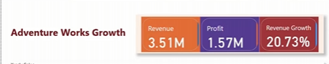
- Highlighting Outliers: Outliers often hold the most important stories within the data. For example, a sudden sales spike in a particular product or a region’s poor performance can reveal market trends, issues, or opportunities. Using Power BI’s color coding, tooltips, or annotations to bring outliers to the forefront ensures that critical points are not missed.
- Providing Access to Detail: Not everyone in your audience will need every granular detail, but Power BI’s interactive elements—such as drill-downs or filters—allow those who do to explore the data further. This balance between high-level overviews and access to more detailed data empowers users and enhances decision-making.
- Adaptability to Preferences: The same dataset can mean different things to different audiences. For example, the executive board might be focused on strategic directions and high-level figures, while the sales team may need more information on regional performance or sales targets. Power BI’s customizability ensures that each presentation can be molded to suit the particular audience’s needs.

Tips and tricks for formatting in reports

Use Power BI themes.
Power BI themes provide a quick way to change the look of the entire report. When you apply a theme, all visuals in your report use the colors and formatting from the selected theme. Use a theme in your report to provide consistency, maintain the brand identity, and get a better user experience and professionalism in your report design. Theme selection also enables you to address accessibility in your reports and dashboards.

The default colors in your report will adjust when you apply a template.
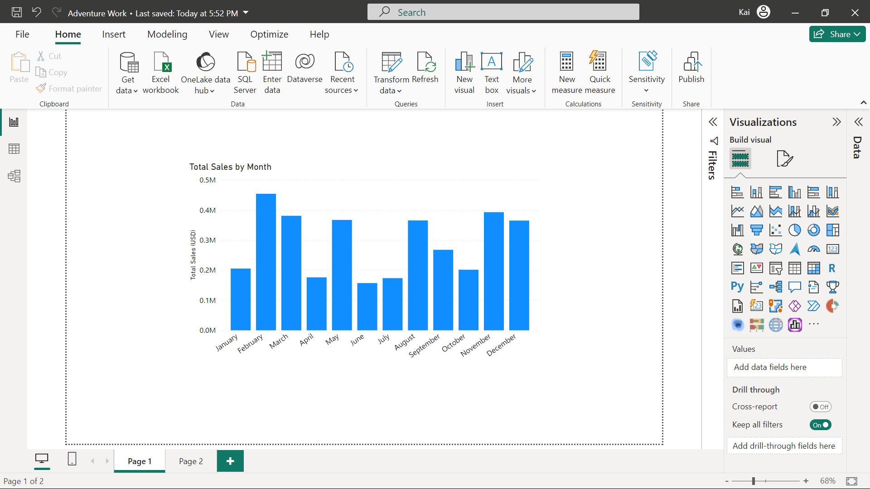
Apply a template from the View tab of Power BI.
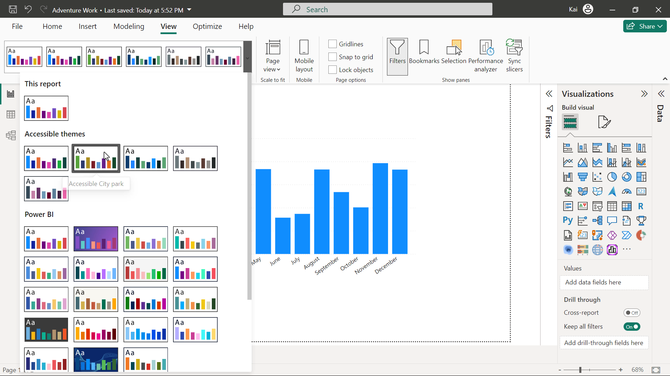
When the template is applied, check the color changes to ensure they match your requirements.
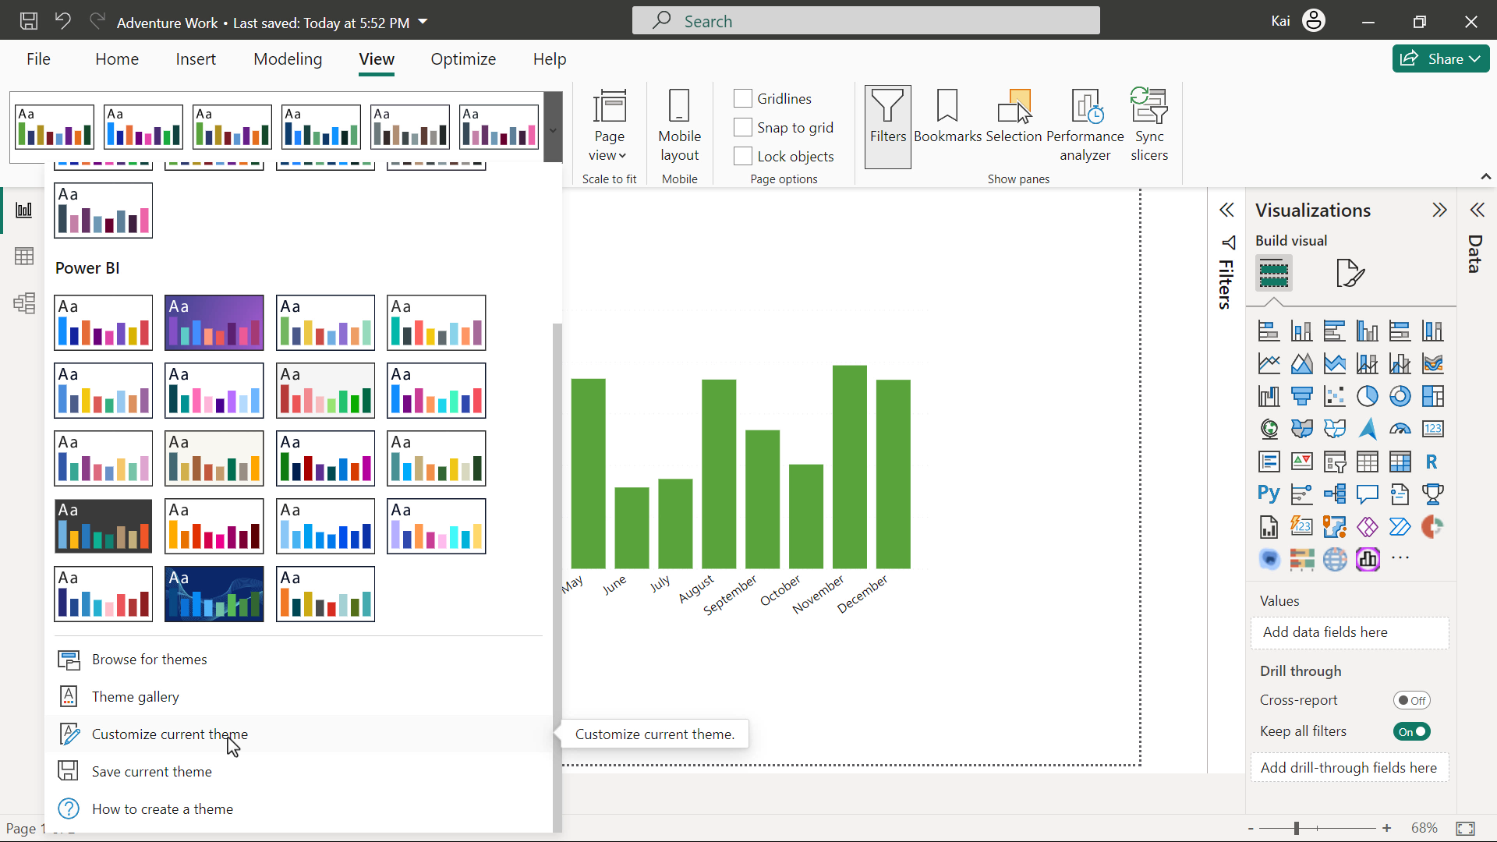
Built-in themes
Power BI desktop has built-in report themes that have pre-defined color schemes. You can customize the theme that you are currently using by changing the hues, saturation, and lightness according to your personal or corporate needs and save the theme in Power BI for later use in other reports.
Custom themes
If your organization has designed its own color palette and wants to create a fully customized theme for all its reports, you can create this using a JSON file and upload it to Power BI.
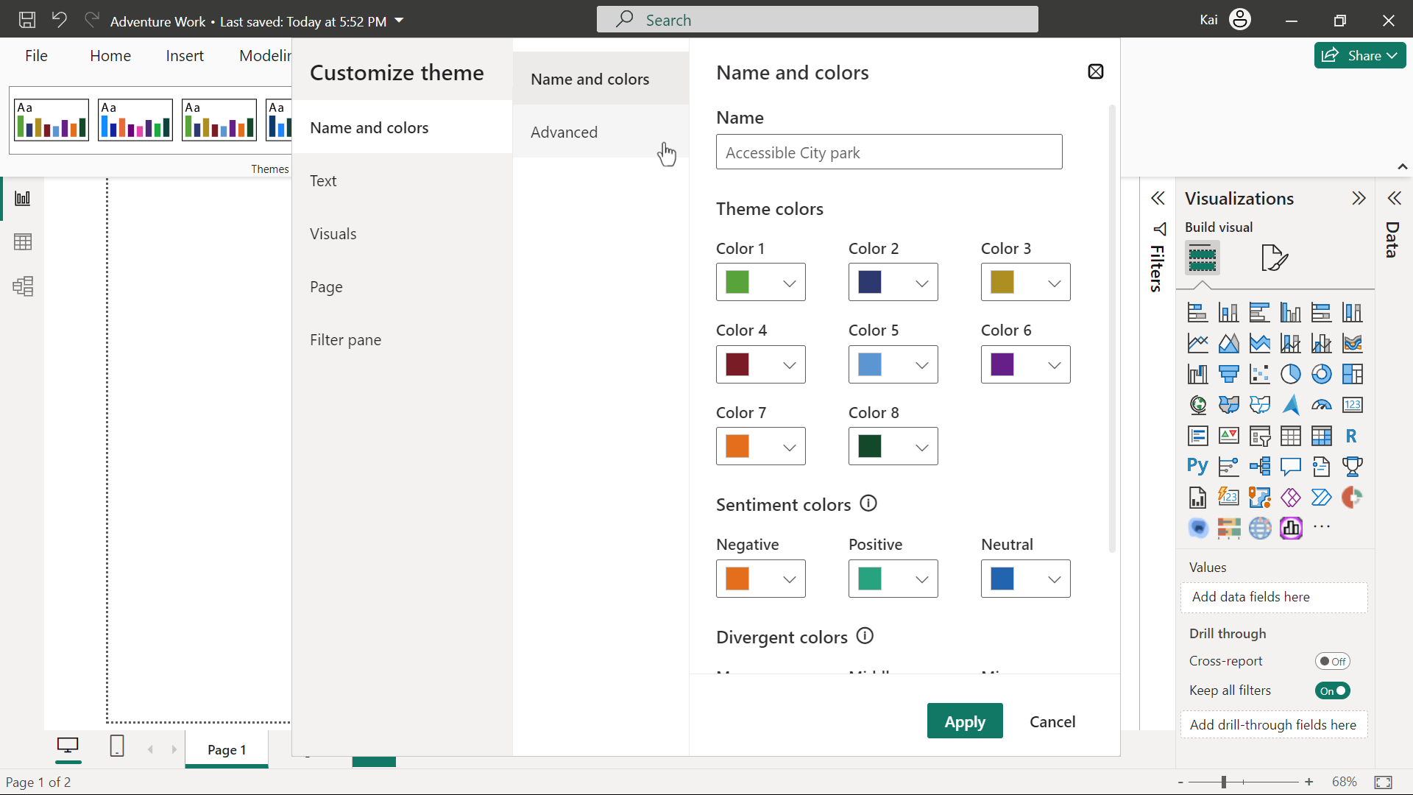

Conditional formatting
Conditional formatting allows you to dynamically change the color of your visual based on specific conditions or rules. This allows you to draw attention to and highlight specific information in numeric or text fields using colors, icons, or bars. You can apply the following formats in conditional formatting:
- Background color
- Font color
- Data bars
- Icons
- Web URL
For example, if Adventure Works wants to analyze the sales of its categories or subcategories, you can apply conditional formatting with a color gradient, the darkest color showing the highest sales and the lightest being the lowest sales values.
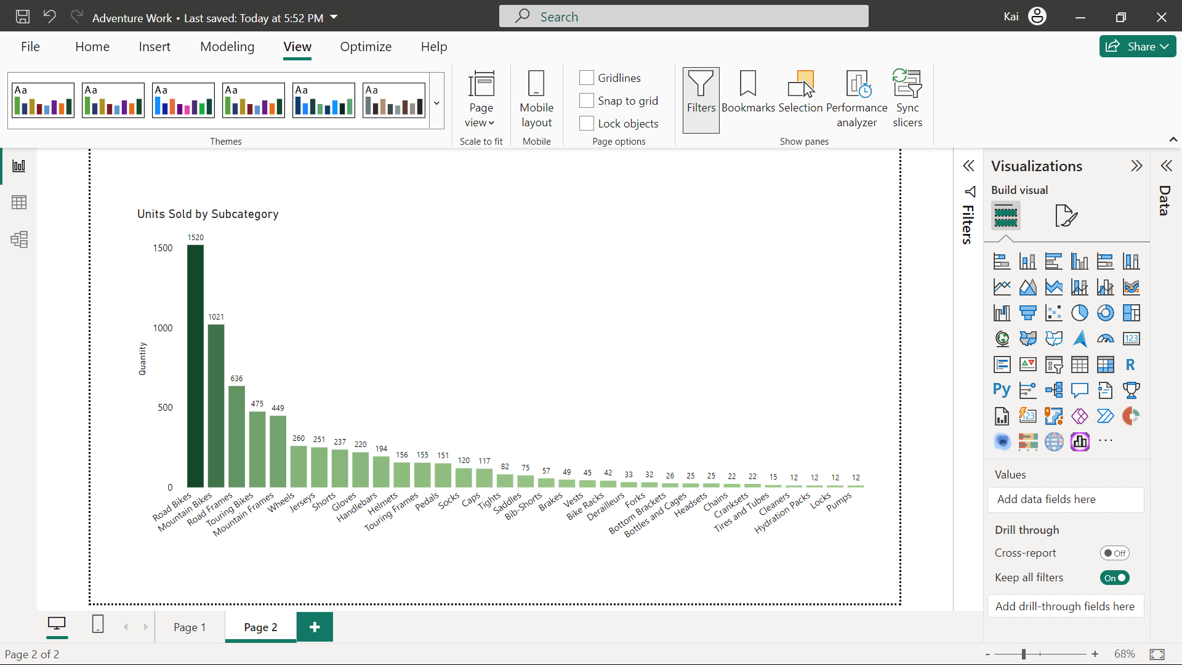

Use of diverging colors
Imagine you are a data analyst in an environmental agency and must analyze temperature data for a specific region. As a temperature range has a neutral midway point, you can use green and red as two extremes of a color gradient in conditional formatting to highlight the positive and negative values within the scale.

In a similar approach to conditional formatting at Adventure Works, you are asked to evaluate the profit margin for each category in each region. Using conditional formatting, you can represent the range of profit margins for each category and region.
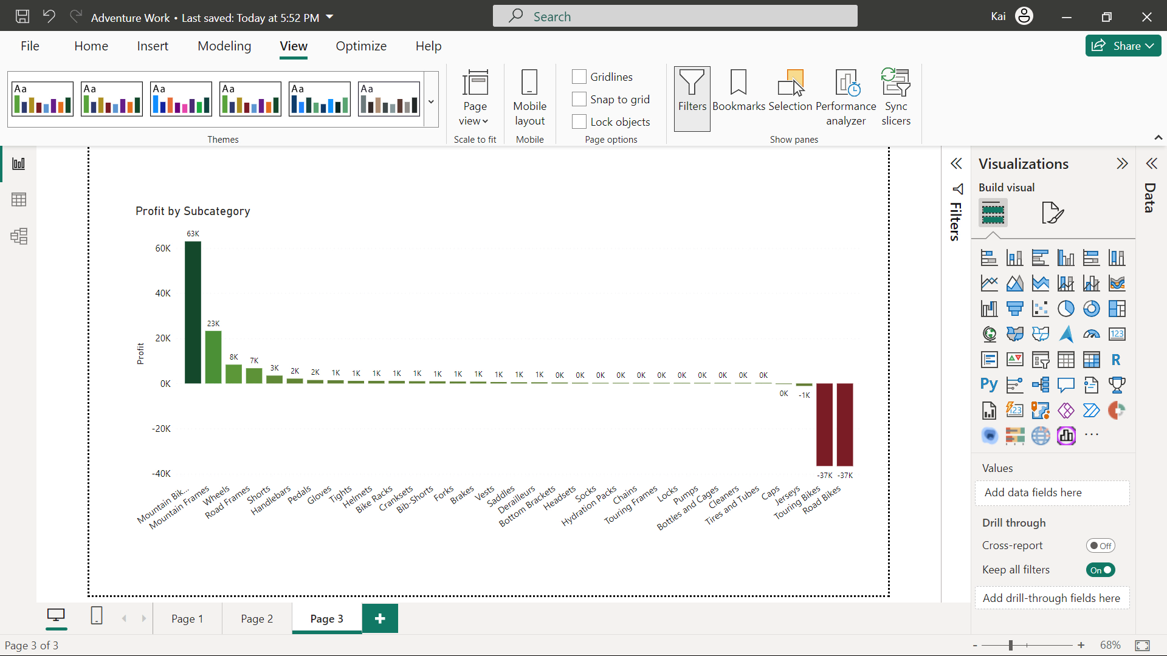
Use of data bars
Data bars give you colored bars like a bar chart. You can set colors for positive and negative values based on maximum and minimum values in your data.
For example, if you want to present the profit margin either as positive or negative without the range, you can apply data bars with red color as negative and green as positive.

Formatting color of individual data points
Conditional formatting changes the color of entire datasets, but what if you want to change the color of only one column or bar in your visual? Power BI provides you with the freedom to accomplish that. For example, at Adventure Works, if you want to highlight one data point to grab the attention of viewers, you can employ selective coloring to all your data points in Power BI.
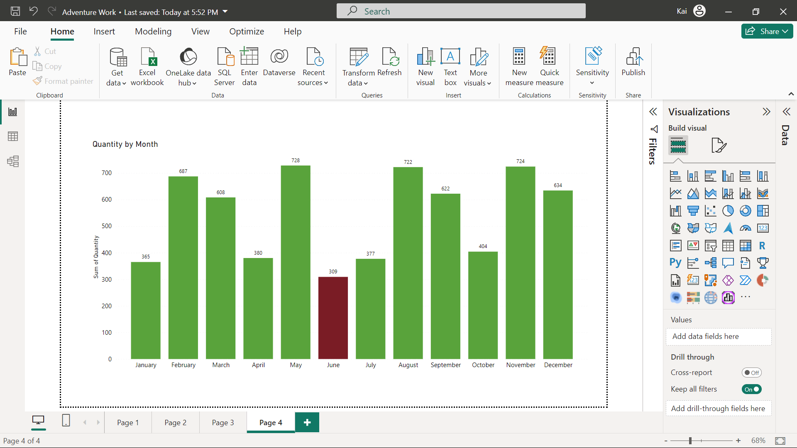
Changing the color of all data points
If your organization has brand colors and wants to use them in all the charts in Power BI, you can color each data point of your visual individually. For example, you want to present the regional sales data for Adventure Works by representing each country with a distinct color.
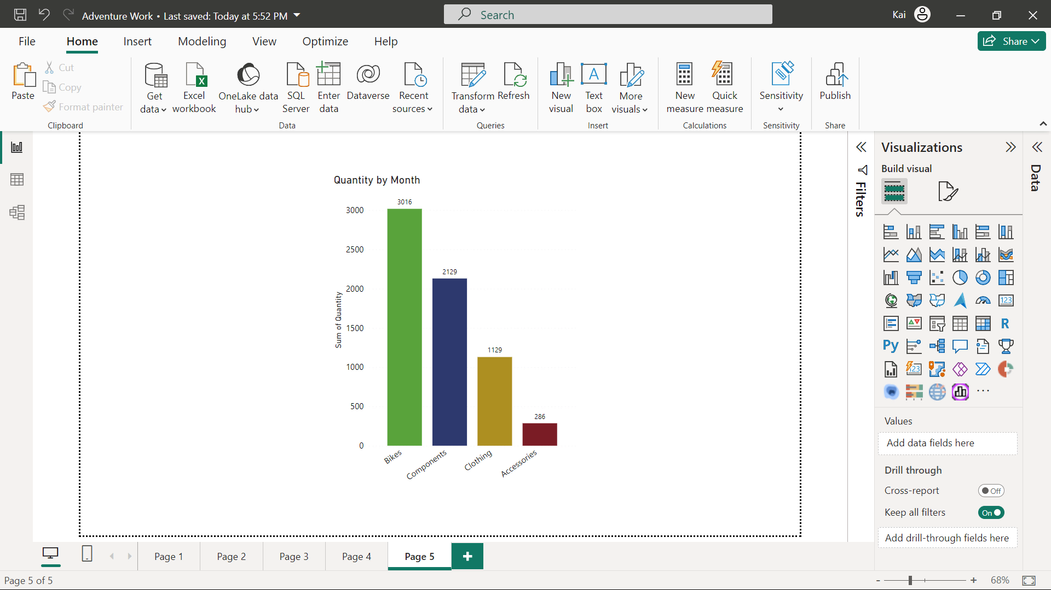

Formatting a table visual
Power BI provides some table-style preset options that you can use as a formatting starting point. Furthermore, you can format column headers and values. In both these categories, you can format background colors and text colors to meet your specific analytical or business needs.
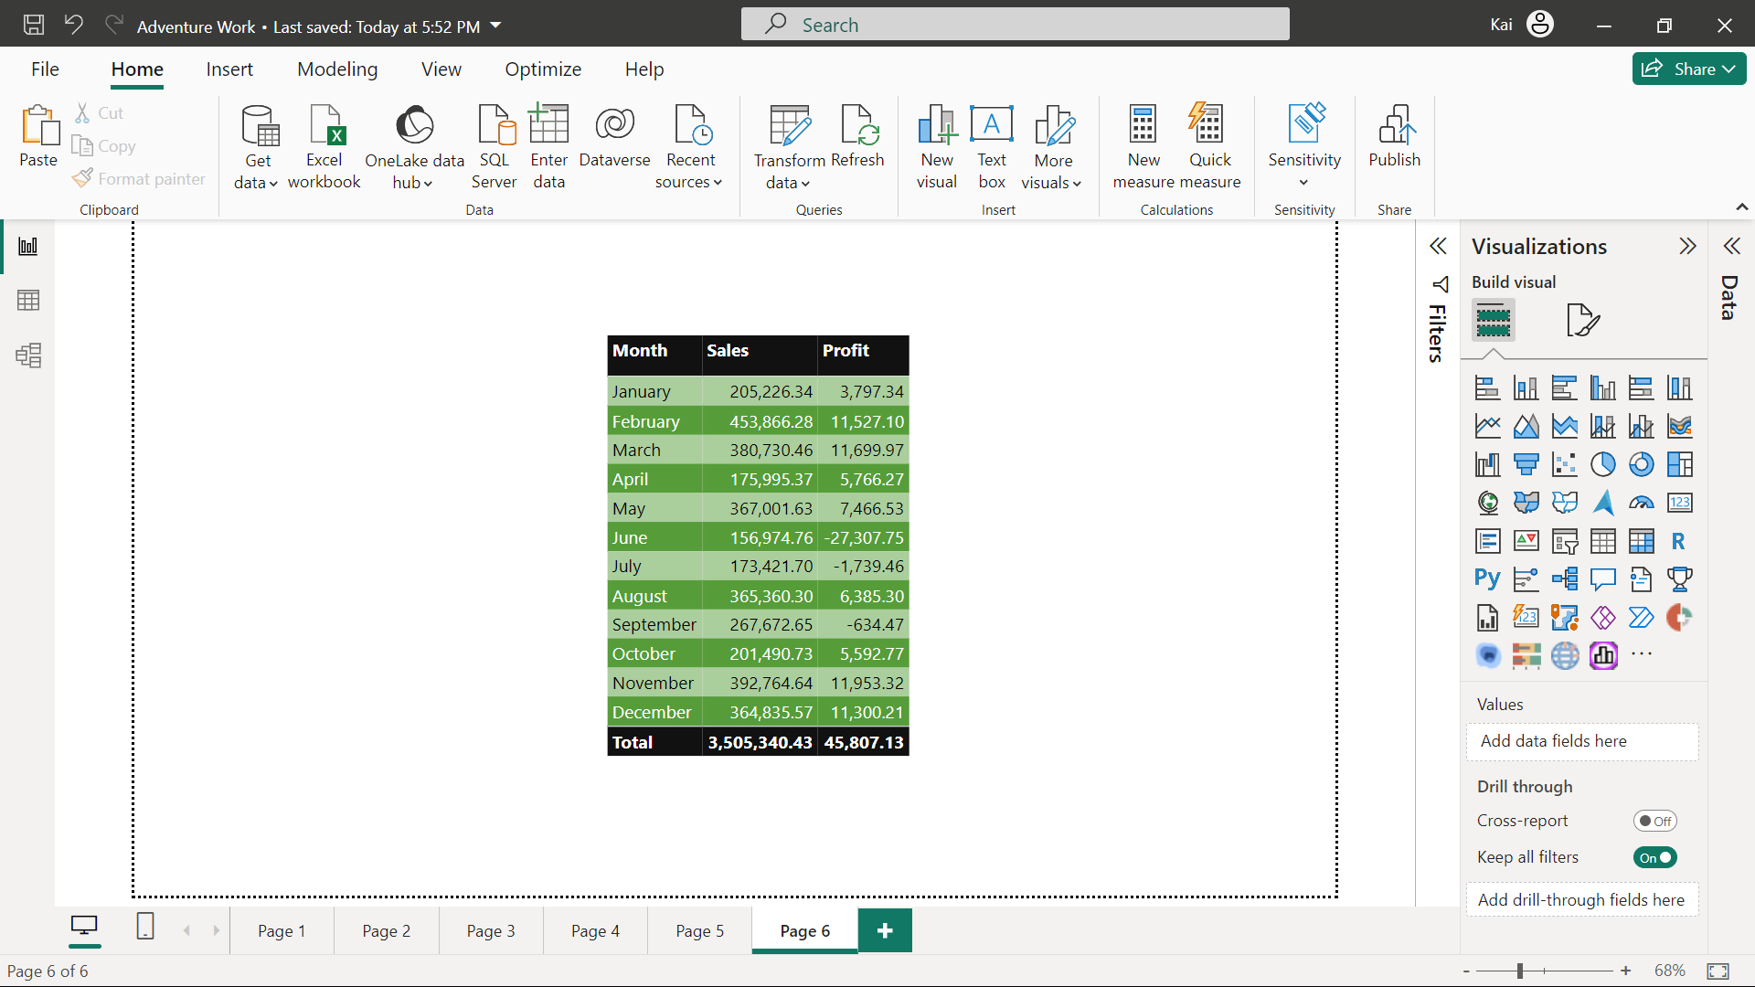
Additional best practices for report formatting
- Consistent color palette: Select a harmonious color palette that aligns with your brand or theme. Consistency in color not only aids the look of the report or dashboard but also helps in associating different visualizations with specific data categories.
- Font choices: Select legible fonts that ensure easy readability across devices. Balance a body font with a header font to maintain the professional appearance of your reports.
- Whitespace utilization: Embrace whitespace to declutter the appearance of reports. Proper spacing between the visuals and text elements prevents visual overload.
- Borders and lines: In reports, the strategic use of borders and lines helps separate various sections, highlight key messages, and guide the viewer’s eye through the report.
- Alignment and grids: Align elements and visuals consistently to create a neat and structured layout. Grids can be helpful in maintaining the uniformity of a Power BI report.
- Background and images: You can incorporate subtle background colors and images that complement your report’s theme. If you are using background colors or images, you need to make sure they are not distracting the viewer from the main message of the report.
- Responsive design: Choose a responsive design that easily adapts to various screen sizes, thereby enabling users to access your work on different devices.

Key Security Aspects in Data Visualization:
- Controlling Access: Just like a vault with restricted keys, access to sensitive data must be tightly controlled. Role-based access control (RBAC) ensures that only authorized individuals can view or interact with specific datasets. At Adventure Works, this means that while the finance team can view financial data, the marketing team accesses customer demographics. Additionally, implementing access logs provides visibility into who accessed the data and when, ensuring accountability.
- Anonymization Techniques: Protecting privacy is crucial, especially when dealing with personally identifiable information (PII). By anonymizing data—whether through generalization, suppression, or noise addition—you ensure that sensitive details are masked while retaining the value of the data for analysis. Adventure Works applies these techniques when conducting market research, allowing them to glean insights without compromising customer privacy.
- Maintaining Data Integrity: The value of data visualization is directly tied to the accuracy of the data it represents. Data validation, error detection, and consistency checks ensure that visualized data remains reliable. For example, by cross-referencing sales data with Adventure Works' CRM system, errors can be caught early, and consistent datasets can be presented. Additionally, using data encryption helps prevent unauthorized modifications during transmission or storage.
- Secure Data Transmission: Sharing data between systems, whether internally or externally, requires secure methods to protect against interception. Using encrypted connections, such as SSL/TLS or HTTPS, ensures that data remains protected during transmission. Adventure Works employs these protocols when collaborating with external partners, maintaining confidentiality and integrity in shared sales data visualizations.
- Compliance with Regulations: Adhering to data protection regulations such as the General Data Protection Regulation (GDPR) is critical. This includes obtaining customer consent, anonymizing personal data, and implementing security safeguards. At Adventure Works, these compliance measures ensure that data is handled lawfully, preserving individuals' rights while still allowing for valuable business insights.
Data integrity encompasses various aspects, including data validation, error detection, and consistency checks.
Positioning is the strategic placement of visual elements within a report to guide the viewer's attention and convey key information.
Color theory is the meaning and usage of colors, and how to pick the best colors in different situations by considering culture, psychology, perception, and more.

Module 2 : Design Powerful report pages

Visual clarity in reports
- Clarity is Key: Insights should be clear and easy to grasp, free from noise or clutter that might obscure the data's meaning.
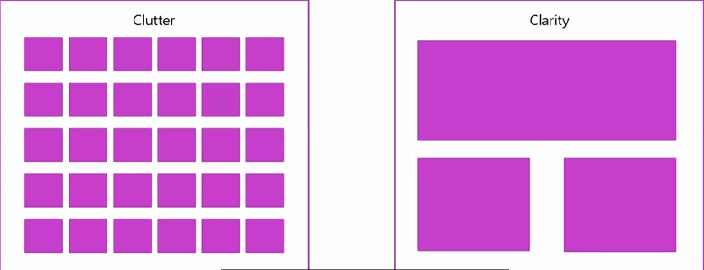
- Chart Selection: Choose the right chart for the data and message. Pie charts, for instance, can be effective for simple breakdowns, but with too many categories, they lose clarity. Always tailor the chart to the data type and the message.

- Avoid Clutter: Overcrowding charts with excessive labels, colors, or complex visuals can confuse the viewer. Streamlined visuals with consistent formatting and appropriate color use ensure clarity.
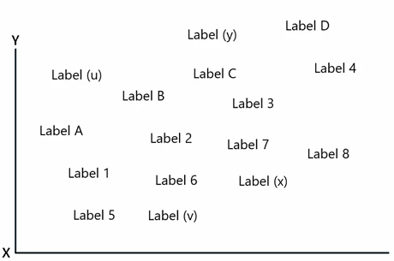
- Drill-Down Functionality: This Power BI feature lets users explore deeper data layers without cluttering the initial visual.
- Data Quality Matters: No matter how well-designed a visual is, it must be built on clean, accurate data. Poor data quality undermines even the most polished presentation.
- Audience Focus: Keep the audience in mind when designing reports. Use visuals they can easily understand based on their familiarity with data visualization.

Creating Power BI reports that are accessible to all users, including those with disabilities, is a key responsibility for data analysts. Here's a breakdown of how to ensure accessibility in Power BI:
- Alt Text for Visuals: Every visual element in your report should have descriptive alt text. This allows screen readers to convey the meaning of visuals to visually impaired users. For example, adding "monthly regional revenue analysis for Adventure Works" to a line chart ensures that users who cannot see the visual can still understand its content.

- Focus Mode and Data Tables: Power BI allows users to expand visuals into full-screen mode using Focus Mode, which helps them view details more easily. Additionally, offering a "Show as a table" option allows users to access the data behind visuals in a screen-reader-friendly tabular format.
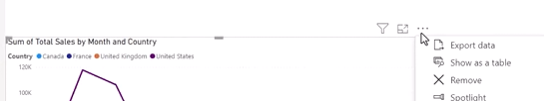
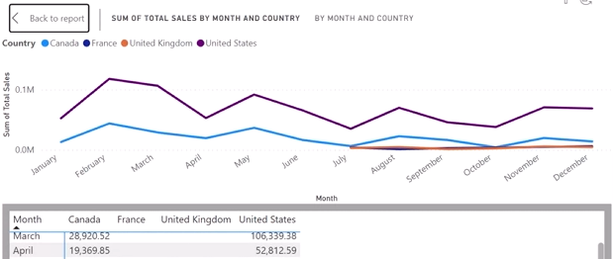
- Descriptive Titles: Report titles, chart titles, and page names serve as reference points for navigation. Using clear and descriptive titles (e.g., "Monthly Sales by Country") helps users with disabilities understand the report structure.
- Markers for Line Charts: Colors alone may not be sufficient for conveying information. For visuals such as line charts, adding markers (e.g., different shapes for each country) makes it easier to distinguish between datasets, especially for users with color vision deficiencies.
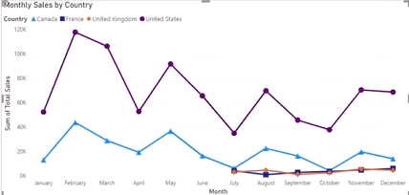
- Tab Order for Keyboard Navigation: The Tab Order feature allows you to arrange the order in which visual elements are accessed through keyboard navigation. This helps users who rely on keyboard shortcuts to navigate your reports logically and efficiently.
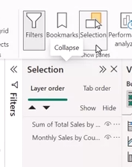
- High Contrast Themes: Power BI’s support for high-contrast modes ensures that reports are readable for users with visual impairments, particularly those with color blindness. Power BI automatically detects and applies the appropriate contrast theme based on Windows settings.
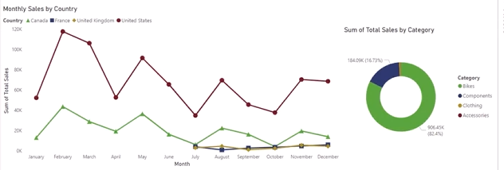
- Testing and Feedback: Testing your reports with a diverse set of users, including those with disabilities, is essential. Gathering real-world feedback can help you identify potential accessibility issues and make necessary improvements.

ฺreakdown of the key strategies and best practices you’ve outlined:

1. Establish Clear Objectives
- Start by defining what you aim to communicate and identifying your target audience. This foundation will guide all design decisions, helping ensure your report stays focused and impactful.

2. Create a Visual Hierarchy
- Use visual cues such as size, color, and position to direct the viewer’s attention to key insights or data points. Larger, more prominent elements signal importance, while color can highlight trends or anomalies. Thoughtful placement helps users navigate through the report with ease.

3. Incorporate Branding and Themes
- Consistency in design is key for credibility and professionalism. Using brand guidelines ensures the report aligns with the company’s identity while maintaining uniformity in colors, fonts, and visual elements.

4. Compose Thoughtfully
- Layout: Proper use of white space, alignment, and an organized structure makes reports clean and engaging. Avoid overcrowding visuals, and keep the design visually appealing.
- Screen Real Estate: Maximize space by presenting essential data while using interactive elements (like slicers, drill-throughs, and tooltips) to provide deeper insights without cluttering the main visuals.
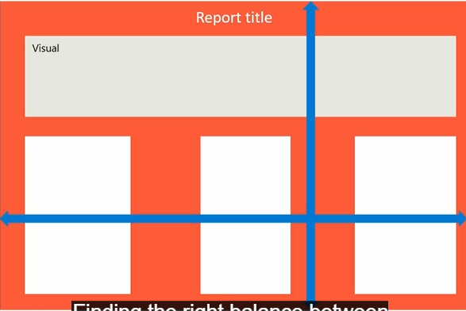

5. Tell a Data Story
- Think of your report as a narrative, with a beginning, middle, and end. Start with an introduction or overview, showcase key insights, support them with additional data, and end with conclusions. Storytelling increases engagement and helps viewers better understand the insights.
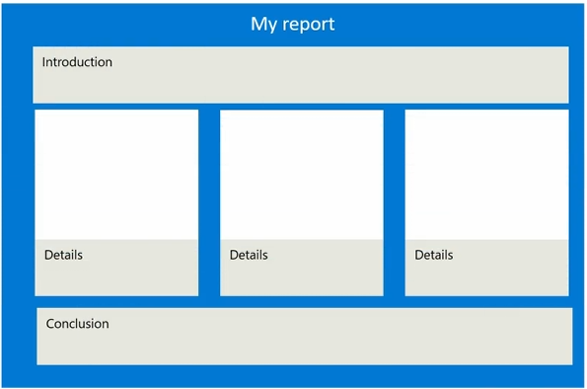

6. Optimize Report Performance
- Slow reports detract from the user experience. Ensure that your reports load quickly and perform efficiently by:
  - Removing unnecessary data.
  - Reducing complex DAX logic.
  - Aggregating data where possible.

7. Select the Right Chart Type
- Choosing the appropriate chart for your data type is crucial:
  - Bar/Column Charts: Best for comparing discrete categories or trends over time. Avoid clutter by limiting the number of categories.
  - Line Charts: Ideal for time series data and trends, but not great for comparing individual data points.
  - Pie/Doughnut Charts: Useful for showing relative proportions but limit the number of categories (eight or fewer).
  - Scatter Plots: Great for identifying relationships between two variables, spotting outliers, and trends. However, they may become overwhelming with too many categories.
  - Gauge Charts: Perfect for showing performance against a target but only suited for single data points.
  - Tree Maps: Excellent for hierarchical data, but they can become complex if the hierarchy is too deep.

8. Maintain Consistency and Cohesion
- Ensure that all elements—fonts, colors, and chart styles—remain consistent across the entire report. This enhances readability and gives your report a polished, cohesive look.

KPI Chart
Creating the KPI Visual:
- Start with total sales and target fields.
- Convert the initial column chart into a KPI visual.
- Populate the KPI with the value (total sales), target (target sales), and trend axis (monthly sales trends).
- Display the most recent value in the trend axis, typically the last month in the dataset (e.g., December sales).
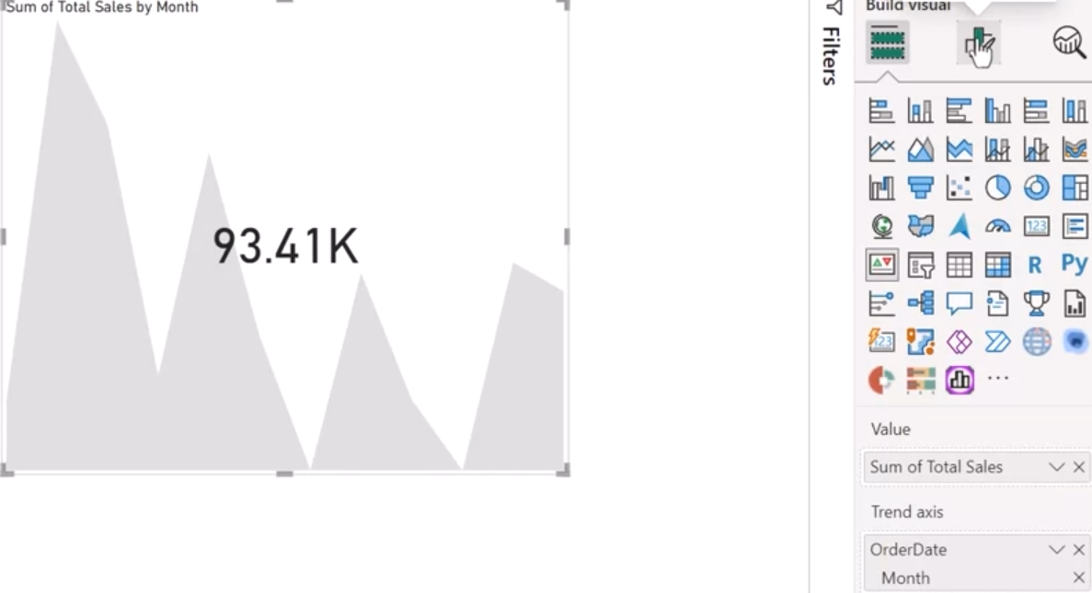
Formatting and Interpretation:
- Customize colors based on performance (e.g., red for underperformance and green for meeting or exceeding targets).
- Display date information for clarity on what period the KPI represents.
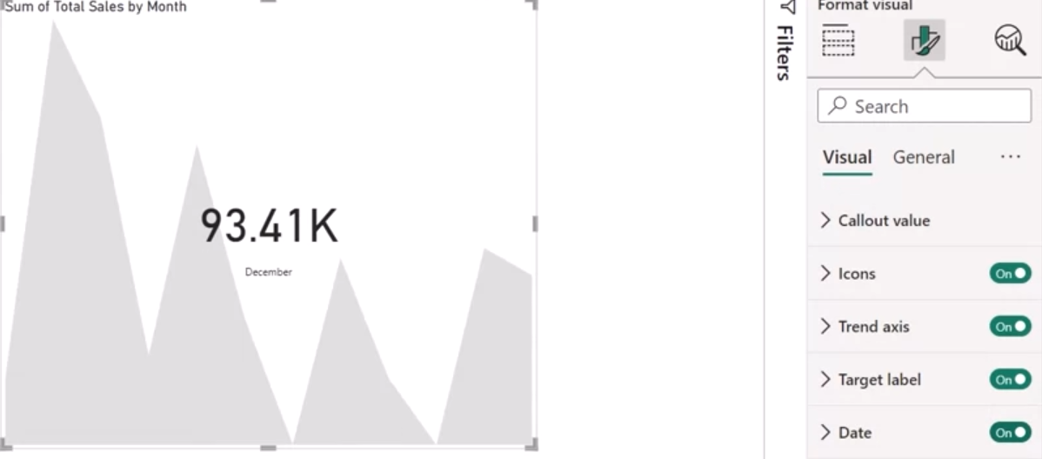
- Show percentage differences between actual performance and the target, helping to quantify performance gaps.
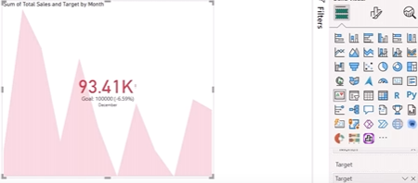
Mobile Optimization:
- Leverage Power BI's mobile layout feature to adjust the KPI visual for smaller screens.
- Focus on uncluttered layouts, optimal font sizes, and ensuring essential data points are clearly visible.
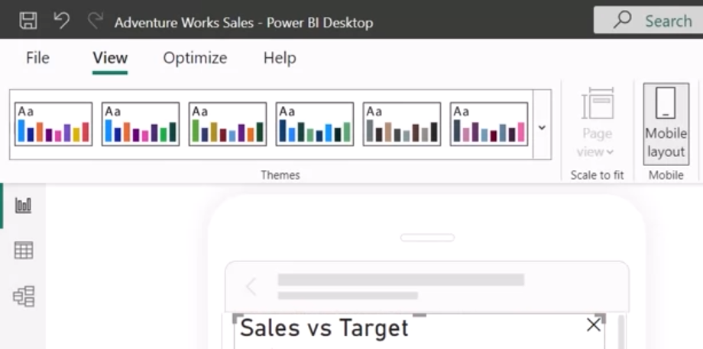

Dot plot chart
This is an excellent use case for a dot plot to visualize AdventureWorks' regional product category sales performance, providing insights into both sales and quantities sold across countries. The dot plot format allows for a concise yet detailed comparison across multiple dimensions, making it ideal for non-technical users and executive-level presentations.
By transforming a scatter plot into a dot plot, you achieved a powerful visual that incorporates:
- Categorical data (e.g., countries and product categories) on the x-axis.
- Numeric values (e.g., sales) on the y-axis.
- Dot size representing another metric (e.g., quantity sold).
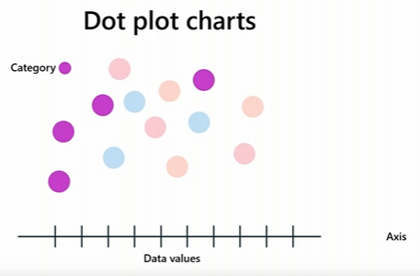

Key steps in creating the dot plot:
- Scatter chart transformation: Converting a scatter plot to a dot plot with categorical data on the x-axis allows for a clear comparison of sales across regions and categories.
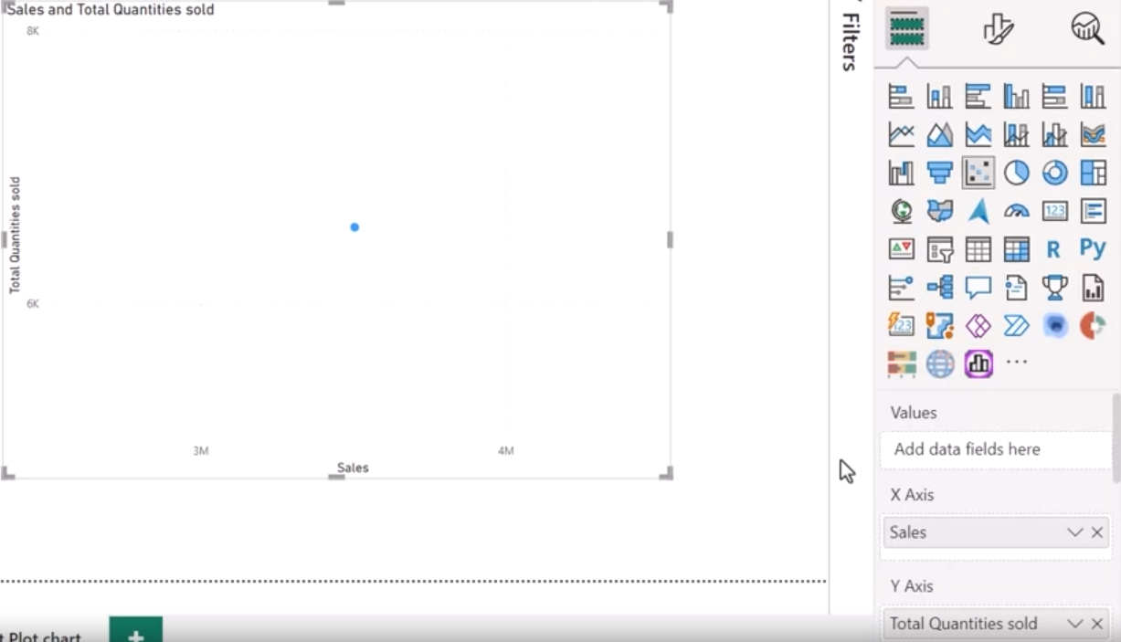
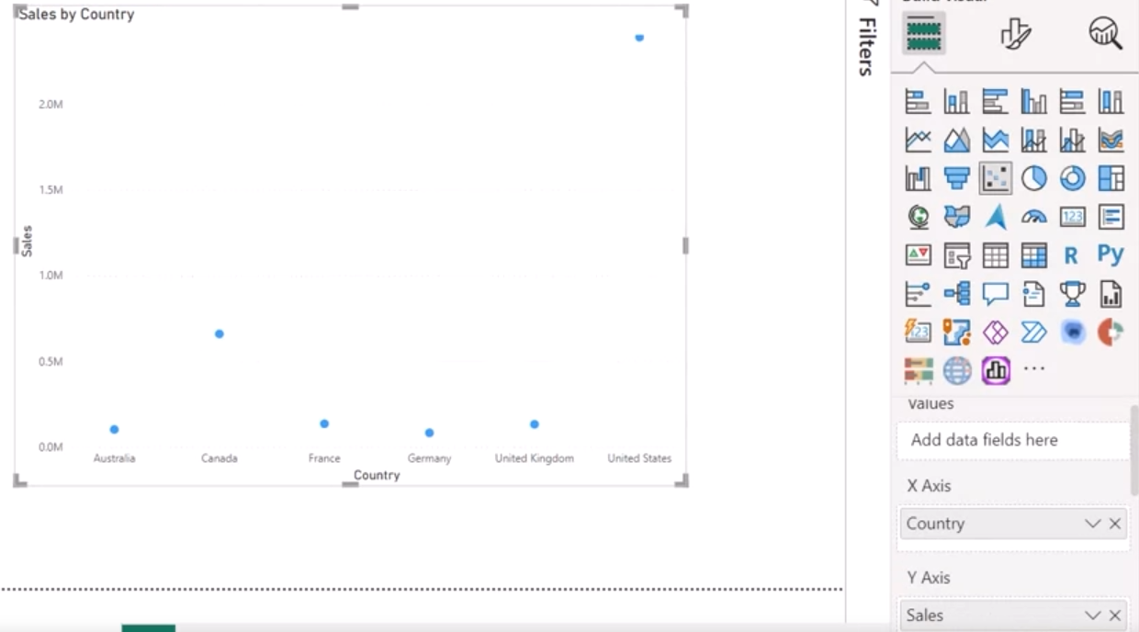
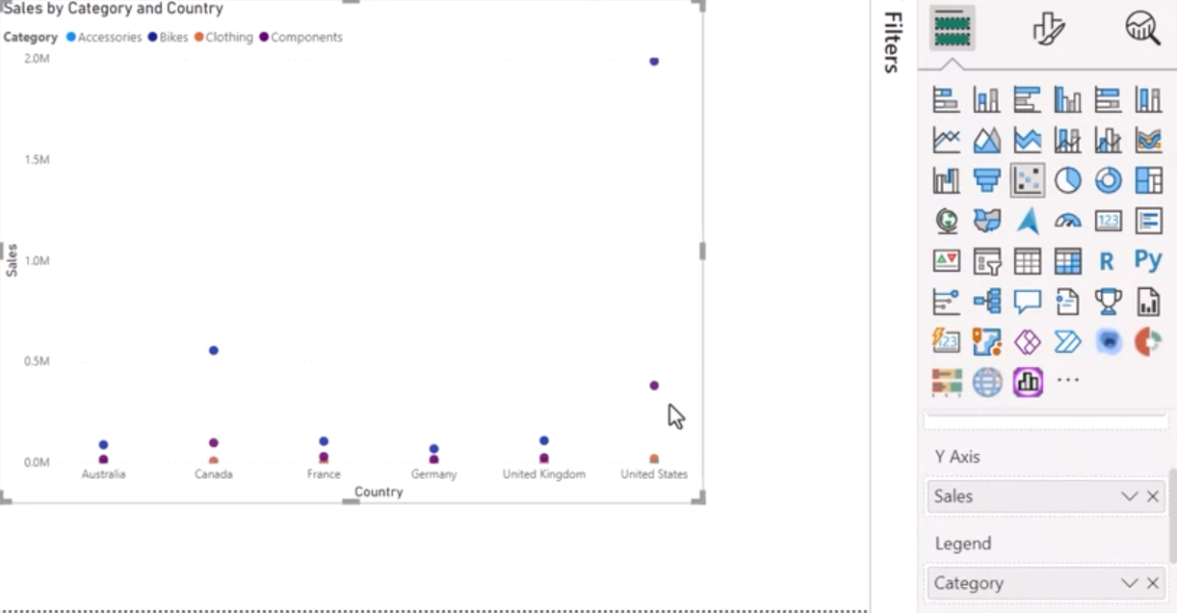
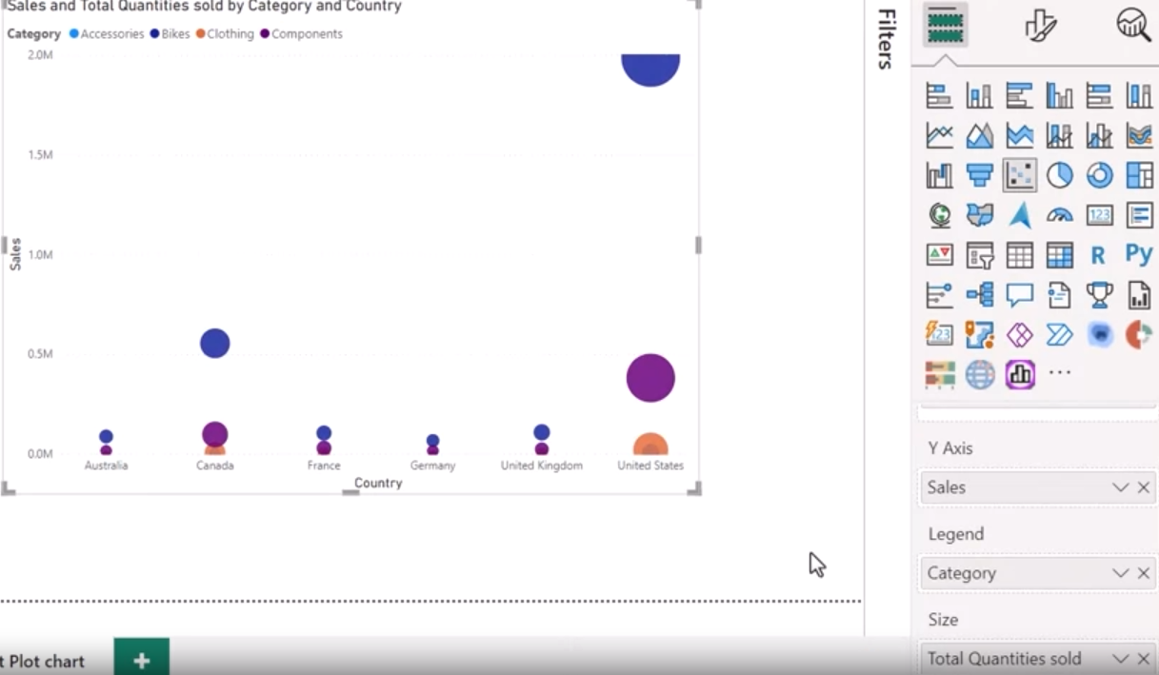
- Marker customization: Adjusting the shape, size, and distinct category markers enhances clarity and accessibility.
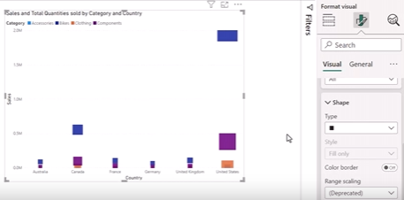
- Tooltip details: By including both sales and quantity sold in the tooltip, you provide immediate insights for each region and category combination.
- Analytics: Adding average lines or other analytics elements highlights trends, making the chart even more insightful.
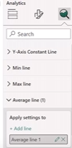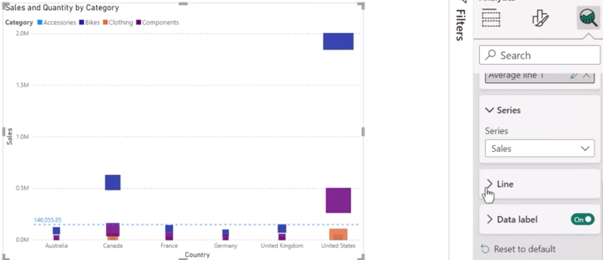
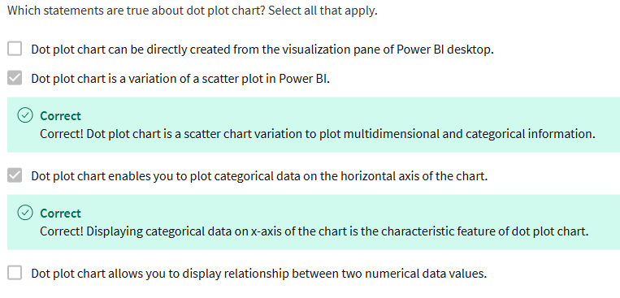
By incorporating multiple data dimensions such as sales, profit margin, product color, and units sold, the bubble chart offers an intuitive way for the management team to interpret complex relationships.

Bubble Chart:
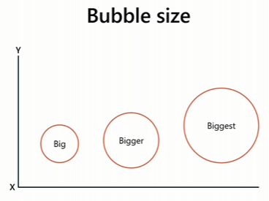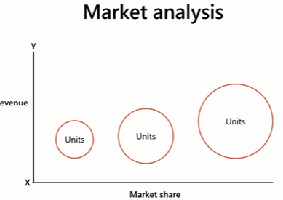
- X and Y Axes: Represent sales and profit margin, offering a clear view of financial performance.
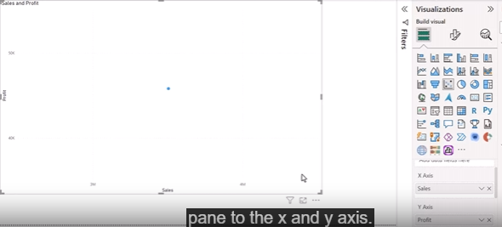
- Bubble Size: Corresponds to the number of units sold, providing an additional layer of analysis.
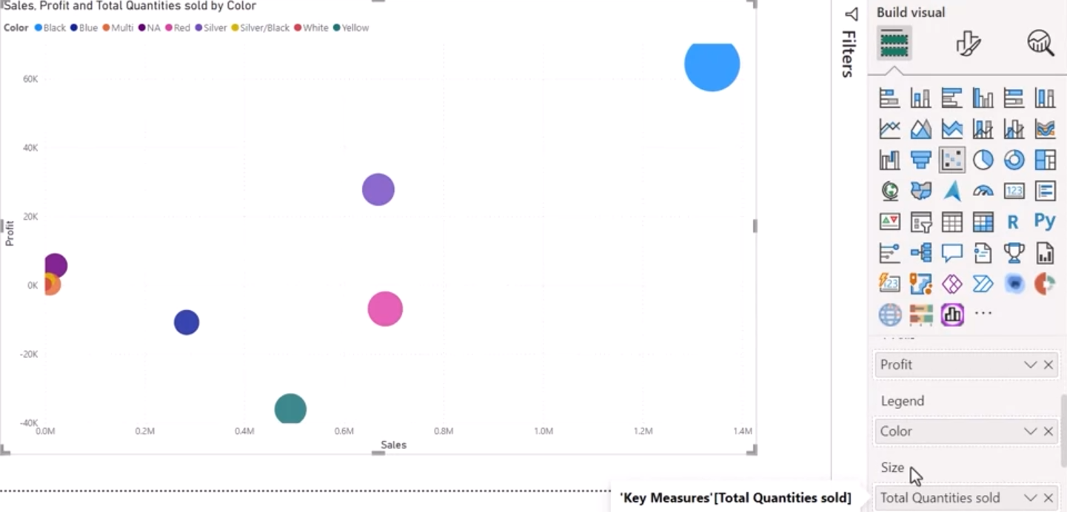
- Legend with Product Color: Categorizing bubbles by product color enables an easy comparison of performance across different product categories.
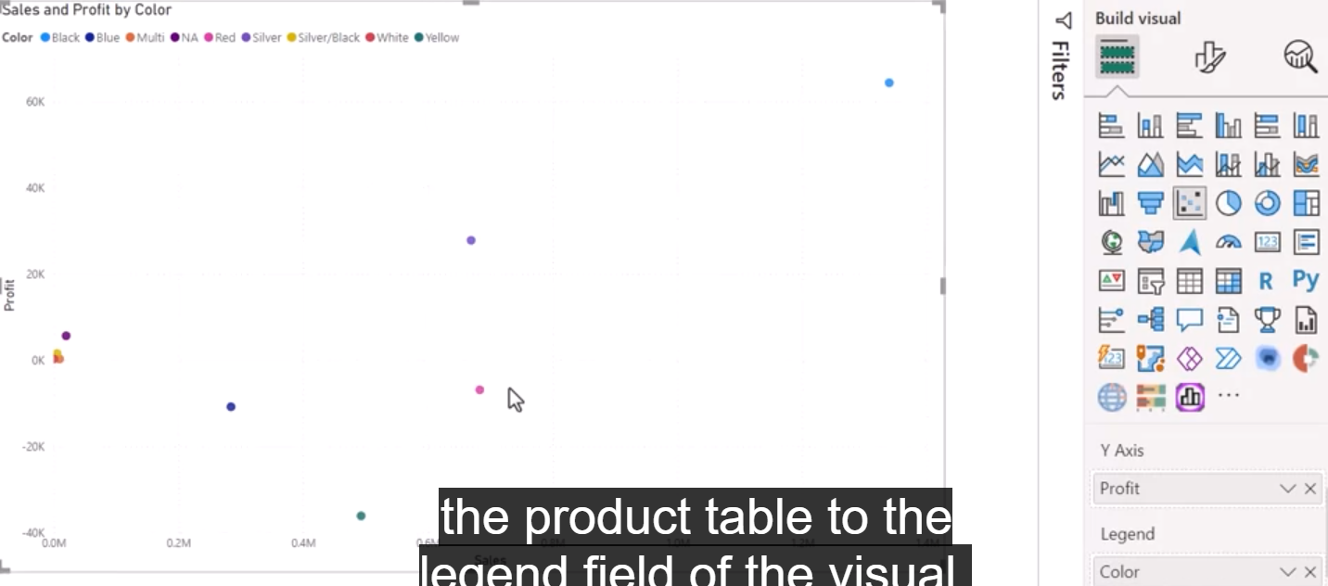
- Play Axis: Adding the year to the play axis allows the chart to be animated, showing how sales, profit margin, and units sold change over time, helping to spot trends or shifts in product performance.
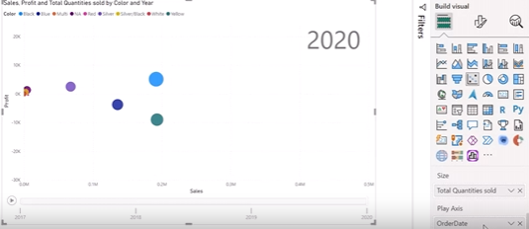
- Analytics: Adding median and average lines for sales and profit margin provides immediate insights into how different product colors perform relative to the average.
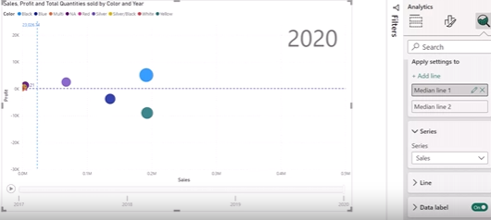
A Bubble chart can present three numerical values, the third numerical value used as the size of the bubble.

แผนภูมิฟอง (Bubble Chart)
- ลักษณะ: เป็นแผนภูมิที่แสดงข้อมูลในรูปแบบของวงกลมหรือฟอง โดยขนาดของฟองจะบ่งบอกถึงปริมาณของข้อมูลนั้น และตำแหน่งของฟองบนแกน x และแกน y จะบ่งบอกถึงค่าของตัวแปรอื่นๆ
- วัตถุประสงค์: ใช้เพื่อแสดงความสัมพันธ์ระหว่างตัวแปรสามตัวขึ้นไป โดยขนาดของฟองจะช่วยให้เห็นภาพรวมของปริมาณได้อย่างรวดเร็ว
- ตัวอย่าง:
  - ธุรกิจ: แสดงยอดขายของสินค้าแต่ละประเภทในแต่ละภูมิภาค โดยขนาดของฟองแสดงยอดขาย จำนวนฟองบนแกน x แสดงประเภทสินค้า และจำนวนฟองบนแกน y แสดงภูมิภาค
  - วิทยาศาสตร์: แสดงความสัมพันธ์ระหว่างอุณหภูมิ ความชื้น และปริมาณฝนตก โดยขนาดของฟองแสดงปริมาณฝนตก ตำแหน่งบนแกน x แสดงอุณหภูมิ และตำแหน่งบนแกน y แสดงความชื้น
แผนภูมิจุด (Dot Plot)
- ลักษณะ: เป็นแผนภูมิที่แสดงข้อมูลในรูปแบบของจุด โดยแต่ละจุดจะแทนค่าข้อมูลหนึ่งค่า และตำแหน่งของจุดบนแกนจะบ่งบอกถึงค่าของตัวแปรนั้น
- วัตถุประสงค์: ใช้เพื่อแสดงการกระจายตัวของข้อมูล แสดงค่ากลาง และค่าผิดปกติของข้อมูล
- ตัวอย่าง:
  - สถิติ: แสดงคะแนนสอบของนักเรียนแต่ละคนในชั้นเรียน โดยแต่ละจุดแทนคะแนนของนักเรียนหนึ่งคน
  - วิศวกรรม: แสดงค่าการวัดของชิ้นงานแต่ละชิ้น

- Bubble Chart:
- ใช้วงกลมหรือ "บับเบิล" แทนข้อมูล
- แสดงความสัมพันธ์ระหว่างตัวแปร 3 ตัว (หรือมากกว่า)
- ขนาดของวงกลมแสดงค่าของตัวแปรที่สาม
ตัวอย่าง: สมมติว่าเราต้องการแสดงข้อมูลเกี่ยวกับประเทศต่างๆ
- แกน X: รายได้ต่อหัวประชากร
- แกน Y: อายุขัยเฉลี่ย
- ขนาดของวงกลม: จำนวนประชากร
ในกรณีนี้ ประเทศที่มีประชากรมากจะมีวงกลมขนาดใหญ่ ตำแหน่งของวงกลมจะแสดงความสัมพันธ์ระหว่างรายได้และอายุขัย

Powerful methods for presenting high-density data
Heat Maps:
- Purpose: Heat maps visually display data density or intensity using color gradients, making them ideal for highlighting patterns and hotspots in large datasets.
- Use Case: For AdventureWorks, a heat map could display sales performance across various regions. Regions with higher sales can be marked with vibrant colors, while lower-performing areas would appear in cooler shades.
- Availability in Power BI: While heat maps aren't part of Power BI's core visualizations, you can import them from the Power BI marketplace or create them using Python-based visuals within Power BI for more customization.
Tree Maps:
- Purpose: Tree maps are effective for displaying hierarchical data and comparing the proportions of categories within a dataset. Each rectangle represents a category, with size corresponding to its value.
- Use Case: AdventureWorks can use a tree map to display sales distribution across product categories and subcategories. This allows viewers to instantly see which categories are contributing the most to overall sales.
Drill Through and Drill Down:
- Drill Down: Enables users to move from a higher level of detail (e.g., yearly sales) to more granular levels (e.g., quarterly, monthly, or daily sales). This is especially useful when a high-level overview needs to be explored in more depth.
- Drill Through: Offers two variations:
  - Chart Drill Through: Allows users to click on a specific data point, such as a product's sales bar in a chart, and drill through to more detailed reports related to that product, such as customer demographics or regional sales.
  - Page Drill Through: Users can navigate from a summary page to a detailed page that provides more granular information, making it useful for report summaries that lead to further exploration.
3D Visualizations:
- Purpose: 3D visualizations add an extra dimension of depth to your analysis, allowing users to better explore relationships between multiple variables.
- Examples:
  - 3D Scatter Plots: These can display products based on factors like price, sales volume, and customer satisfaction, helping to uncover relationships between multiple dimensions.
  - 3D Maps: Interactive maps with three-dimensional elements provide a richer understanding of geographical trends, such as visualizing sales performance across countries or regions with elevation data to indicate intensity.
Practical Scenario for AdventureWorks:
For AdventureWorks, these advanced techniques can improve the interpretation of their high-density sales data:
- Heat Maps can highlight geographical sales performance across various regions.
- Tree Maps will help break down sales by product categories, making it easier to identify the top-performing products.
- Drill Through and Drill Down techniques will allow management to explore sales trends by year, quarter, and month while diving deeper into specific products or regions.
- 3D Visualizations will offer a new perspective on multidimensional data like sales, customer feedback, and product pricing, providing valuable insight into overall performance.

Optimizing Report layout for mobile

Navigate to Mobile Layout: Go to the View tab and select "Mobile Layout" to access the mobile layout Canvas.
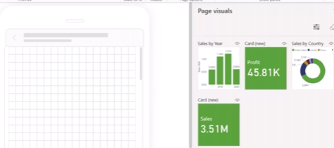
Organize Visuals: Use the mobile Canvas to drag and drop the visuals from the page visual pane. You’ll need to position each element carefully:
- Cards: Start by placing the two-card visuals (sales and profit) side by side at the top of the mobile screen.
- Column Chart: Add the yearly sales column chart next, aligning it below the cards and filling the screen width.
- Donut Chart: Finally, position the donut chart (sales by country or region) below the column chart, adjusting its size to fit the screen.
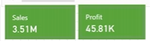
Adjust Font Sizes: Ensure readability on mobile by adjusting font sizes:
- For card visuals, set the value font size to 18 and label font size to 12.
- Adjust spacing to maintain a clean design with readable data points.
Optimize Legends and Labels: For the donut chart, relocate the legend to the "Center left" position to ensure all values are visible without the need for additional navigation. Adjust font sizes where needed.
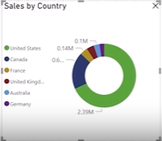
Lock Visuals: Once you’re satisfied with the placement and scaling, lock the objects in place to prevent accidental changes.
Test on Multiple Devices: Before finalizing, test the mobile-optimized report on different devices to ensure responsive design and consistent usability.

Map Visuals

Shape Map Visuals

Introduction
Shape map visuals in Power BI allow for enhanced geographical data representation, making them ideal for analyzing aspects like population density, competitor locations, and market demand. Unlike traditional maps, shape maps let you work with custom regions, enhancing storytelling through data visualization.

Enabling Shape Map Visual
- Open Power BI Desktop.
- Go to File > Options and Settings > Options.
- Under Global, select Preview features.
- Check the Shape map visual box and click OK.
- Restart Power BI Desktop.
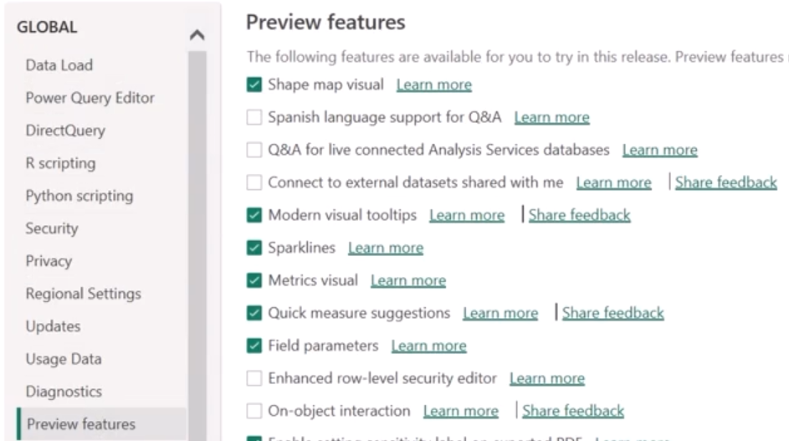

Adding a Shape Map Visual
- Once Power BI has restarted, go to the Visualizations pane.
- Click on the Shape Map icon to add a placeholder to your report canvas.

Configuring the Shape Map
- Add Data Fields:
  - Drag the State field to the Location well.
  - Drag the Sales field to the Color saturation well.
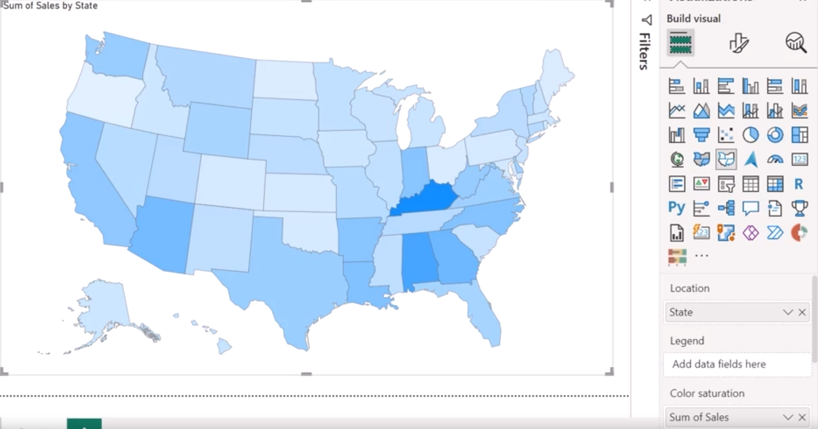
- Change Color Scheme:
  - Navigate to the View tab and select a more accessible color scheme (e.g., Accessible City Park).
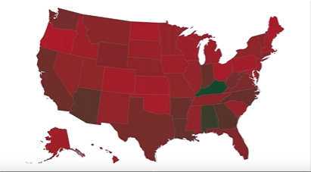
- Apply Gradient Colors (if no additional categories are available):
  - Go to Format visual > Visual > Fill colors.
  - Turn on the Gradient toggle and set:
    - Minimum: Light Blue
    - Center: Purple
    - Maximum: Black
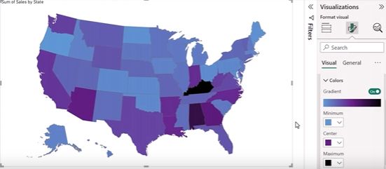
  - Adjust the Border color to black with a width of 3.
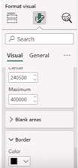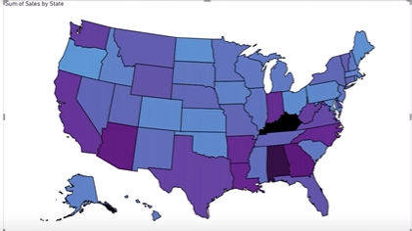
- Display Map Keys:
  - Click on the Map settings dropdown and enable View Map Type Key to display keys for U.S. states.
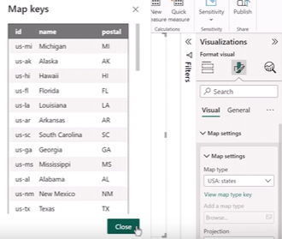
  - Change the map type if necessary.
- Projection Options:
  - Select from available projection styles (e.g., Albers USA, Equirectangular, Mercator, Orthographic).
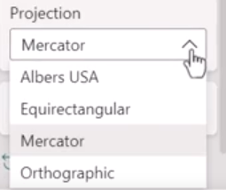
- Zoom Features:
  - Access the Zoom dropdown and enable Zoom on selection and Manual zoom.
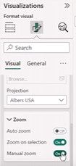
- Format Chart Title:
  - Go to General tab > Title dropdown to customize title properties.
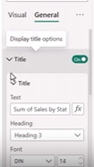

Choropleth maps

Introduction
Choropleth maps, also known as field maps, are powerful tools for visualizing spatial patterns by color-coding geographical regions based on data values. They provide a compelling way to represent variations in data across different locations, making it easier to identify trends and insights.
Purpose and Use Cases
AdventureWorks executive management recognizes that raw data in tables or charts fails to convey regional sales distribution effectively. Choropleth maps can solve this issue by displaying sales data geographically, helping to communicate variations in performance across different territories.
Key Use Cases:
- Population Distribution: Visualizing population density or total population across regions to identify densely and sparsely populated areas.
- Economic Indicators: Displaying metrics like GDP, unemployment rates, and poverty levels to highlight economic disparities and inform decision-making.
- Health and Education Metrics: Illustrating disease prevalence, vaccination rates, literacy levels, and school enrollment to identify regional challenges.
- Environmental Data: Showing air quality, temperature variations, or pollution levels to assist in assessing environmental conditions.
Choropleth Map Features
- Geographical Representation: Each area (country, state, region) is shaded based on specific data values, enabling quick identification of patterns.
- Color Coding: The intensity of the color represents the magnitude of data values, allowing easy comparisons and highlighting disparities.
- Clear Legends: Providing a legend or data scale is essential for helping users interpret the map and understand the relationship between colors and data values.
Best Practices for Designing Choropleth Maps
- Color Selection: Choose colors or patterns that are easy to interpret and distinguish. A smooth color scale enhances readability.
- Geographic Boundaries: Ensure the data being visualized has clear geographic boundaries for the map to be effective.
- Data Interpretation: Include a clear legend to assist viewers in understanding what the colors or patterns represent.
Applying Choropleth Maps at AdventureWorks
For AdventureWorks, choropleth maps can be particularly useful in visualizing sales performance. For example:
- Sales Breakdown: Display sales performance per country and state, with darker shades representing higher sales and lighter shades indicating lower sales. This visual representation can facilitate better decision-making regarding market strategies and resource allocation.

Selecting the Right Data for Analysis
Before creating a choropleth map, it’s crucial to select appropriate data for analysis. In the context of AdventureWorks, the company aims to understand sales performance across various regions within a specific country.
Data Requirements:
- Geographical Regions: One column should represent the geographical regions (e.g., states).
- Quantitative Data: A second column should contain relevant quantitative data, such as total sales or revenue for each region.
Preparing the Data Model
Creating an effective data model is foundational for compelling visualizations. Ensure that:
- The regions column is in text format and contains names or codes that match the geographical data visualization.
- The quantitative data column is in numerical format for accurate analysis.
Steps to Create a Choropleth Map in Power BI
- Enable Map Visuals:
  - Navigate to File > Options and Settings > Options > Global > Security.
  - Check the option for Use Map and Filled Map Visuals.
- Loading the Data:
  - Ensure your AdventureWorks dataset contains the following:
    - State (Geographical Regions)
    - Sales (Quantitative Data)
- Creating the Choropleth Map:
  - Go to the Visualizations pane and select the Filled Map option. Power BI will automatically detect the columns representing geographical regions and quantitative data.
  - Drag the State field to the Location well and the Sales field to the Tooltip well.
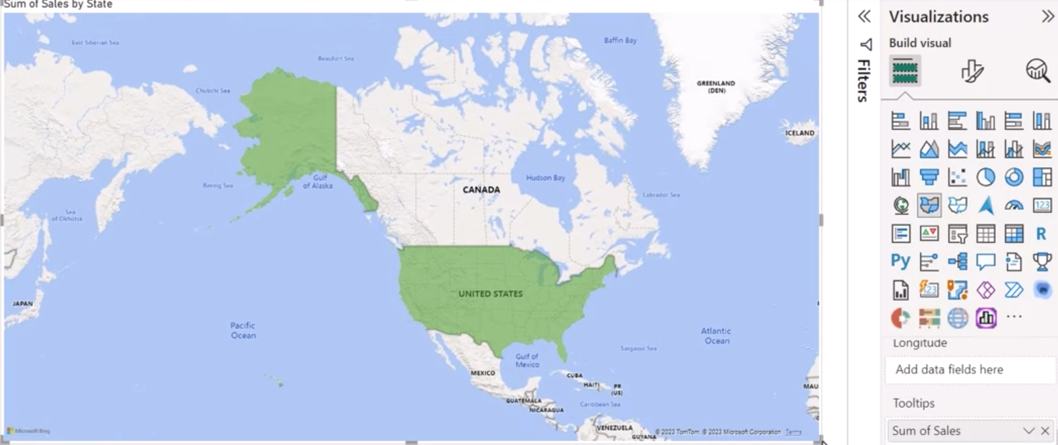
- Customizing the Visualization:
  - Go to Visualizations > Format Visual > Visual.
  - Select Fill Colors, then click on the FX icon to apply conditional formatting.
  - Create rules based on the sales values:
    - Rule 1: Sales between $80,000 - $149,000 (Color: Yellow)
    - Rule 2: Sales between $150,000 - $249,000 (Color: Red)
    - Rule 3: Sales from $250,000 - $400,000 (Color: Purple)
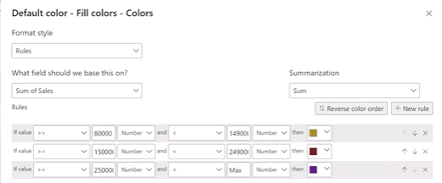
- Selecting Map Style:
  - Expand Map Settings, and in the Style dropdown, select the desired map style (e.g., Aerial, Dark, Light Gray Scale, or Road).
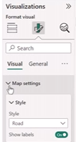
  - Adjust zoom settings: Turn Auto Zoom off and enable Zoom Buttons and Lasso Tool for manual zoom control.

- Enhancing Map Informative Value:
  - Customize the color scale to represent varying sales levels, using darker shades for higher sales and lighter colors for lower sales.
  - Format the map title and add a clear legend to convey information effectively. Access the General tab, expand the Title dropdown, and format as needed.
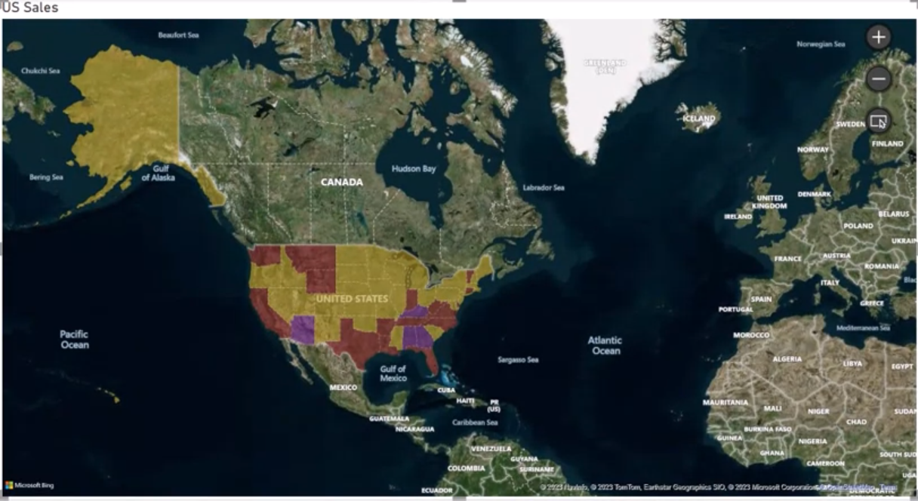

Tips on Map visualizations
Map visuals, especially when dealing with geographical information, can unlock a wealth of insights, making them indispensable for businesses like AdventureWorks. As the company operates stores across various cities and states, the North American sales manager has tasked you with presenting a report that analyzes sales across multiple regions. In this tutorial, you will create a comprehensive geo hierarchy using Power BI’s filled map visual to drill down from country to state and city, providing a detailed sales analysis.
Preparing the Data: AdventureWorks Sales Data
To start, open Power BI and load the project AdventureWorkSales.pbix. The report contains two key data tables:
- FactInternetSales: Includes sales transaction data.
- Geography: Includes geographical details like country, state, and city.
In map visualizations, ensuring location accuracy is essential, especially with ambiguous names such as Southampton (which exists in England, Pennsylvania, and New York). While adding longitude and latitude coordinates can resolve such conflicts, you can alternatively format geographical columns appropriately for Power BI to understand the data.
Formatting Geographical Data
- Set Data Category for Geographical Fields:
  - In the Geography table, select the Country column.
  - Navigate to the Column Tools tab, and in the Data Category dropdown, select Country.
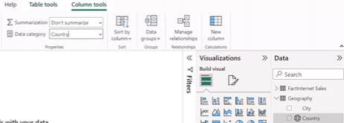
  - Repeat this process for the State/Province Name and City columns, assigning the respective data categories (State/Province and City).
  - A globe icon will appear next to the field names, indicating that Power BI recognizes the geographical data type.
- Formatting Sales Data:
  - In the FactInternetSales table, select the Sales Amount column.
  - Format the data type as Currency with two decimal places.
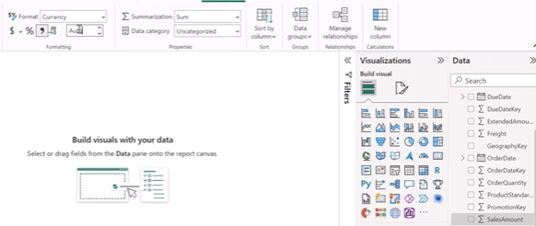
Creating the Filled Map Visualization
- Adding the Map Visual:
  - In the Visualizations pane, select the Filled Map visual to create a map placeholder on the report canvas.
  - Enlarge the map placeholder for better visibility.
- Building the Geo Hierarchy:
  - Drag the following fields from the Geography table to the Location well in this order:
    - Country
    - State/Province Name
    - City
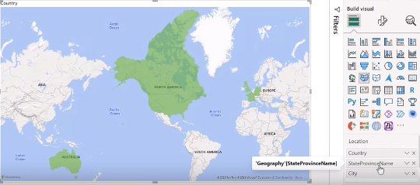
  - This creates a hierarchy that allows for drilling down through geographical layers.
- Adding Sales Data:
  - Drag the Sales Amount field from the FactInternetSales table to the Tooltip well of the map visual.
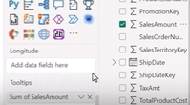

Customizing the Map for Better Insights
- Conditional Formatting:
  - Open the Conditional Formatting dialog by selecting the FX icon next to Fill Colors.
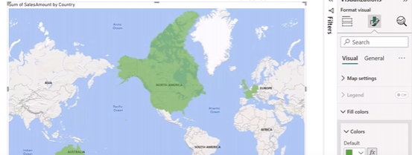
  - Apply the following color rules:
    - Yellow for the minimum value.
    - Red for the middle value.
    - Purple for the maximum value.
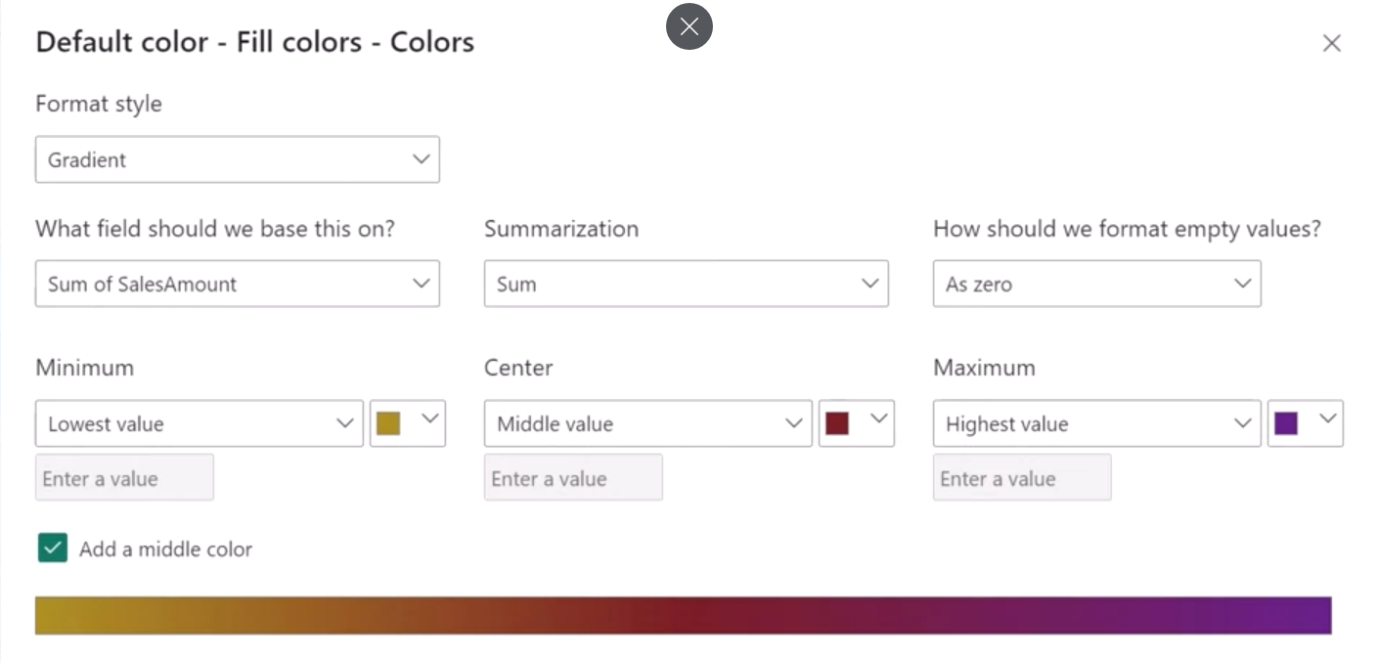
- Filtering Data:
  - You want to show sales data for the United States only. In the Filter Pane, under Country, select United States to restrict the map to US regions.
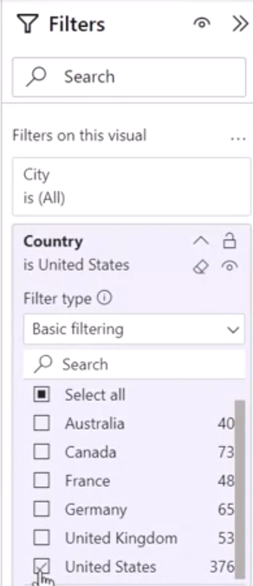
Drilling Down in the Geo Hierarchy
- Enable Drill Down Mode:
  - At the top right of the map visual on the report canvas, click the Downward Arrow to enable drill-down mode. The arrow will have a black background when activated.

- Navigating through the Hierarchy:
  - Drill to Next Level: Click the Double Parallel Arrow to drill down from the country level to the state level. For instance, selecting the United States drills down to individual states.
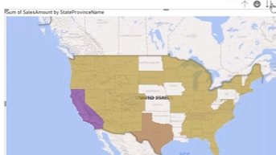
  - Manual Drill: Hover over a state like California to display its sales value in the tooltip. To drill further into cities, click the Drill Down icon or use the tooltip’s drill-down option.
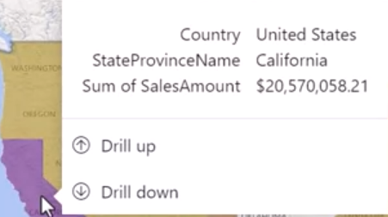
- At the city level, the map will display sales data for individual cities. Note that the drill-down color remains consistent with the previous level, which may require modification for better accessibility.
- Finalizing the Hierarchy:
  - If needed, you can add more granular layers like postal codes or individual stores to the hierarchy for a more detailed analysis.

Accessing the Map
Formatting the Map Visual: Exploring Control Options
- Accessing the Map Settings:
  - In Power BI, navigate to the Visualizations pane and select Format Visual.
  - Expand the Map Settings dropdown to explore customization options.
- Choosing a Map Style:
  - In the Style dropdown, Power BI offers five map styles: Road, Dark, Light, Aerial, and Grayscale.
  - By default, Road style is selected. For this demonstration, let’s select Aerial from the list to provide a satellite view of the regions.
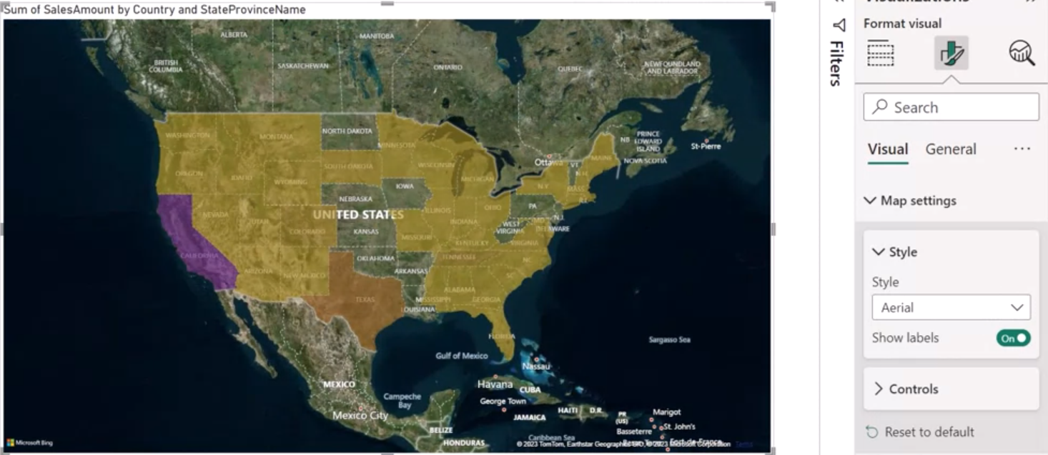
- Configuring Zoom Controls:
  - Expand the Control section to reveal the map’s zoom options:
    - Auto Zoom: This is turned on by default, ensuring the map automatically adjusts based on the data displayed.
    - Zoom Buttons: Turn this option On to manually control zoom levels on the map.
    - Lasso Button: Turn this option On to allow users to highlight specific areas of interest with a lasso tool.
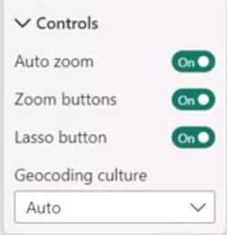
- These controls give users more flexibility in focusing on a specific region or city.
- Geocoding Culture:
  - The last option in the map settings is Geocoding Culture, which Power BI sets to Auto by default. Leave this setting as is, as it ensures the appropriate geographical settings are applied based on the data.
Formatting Colors in the Map Visual
- Conditional Formatting:
  - Open the Conditional Formatting dialog box to modify the color scheme representing sales data across states and cities.
  - Currently, the map uses a color gradient where:
    - Yellow represents the states with the lowest sales values.
    - Purple represents the states with the highest sales values.
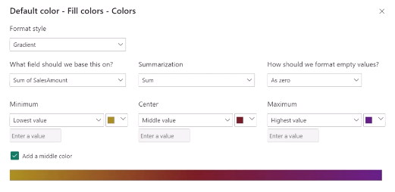
- This color coding provides clear visual cues for interpreting the sales performance across regions.
- Renaming Fields and Titles:
  - To make the visual clutter-free and easier to interpret, rename the labels in the map:
    - Double-click on the State/Province Name field in the Location well and rename it to State.
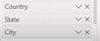
    - In the Tooltip field, rename Sum of Sales Amount to Sales.
- These changes simplify the presentation of data and make the map more user-friendly.
- Updating the Title:
  - Go to Visualizations, then Format Visual, and expand the General section.
  - Change the map’s title to something more descriptive, like Sales Distribution by Location, to clarify the purpose of the map.

Customizing Tooltips for Enhanced User Experience
- Formatting Tooltips:
  - Tooltips provide additional information when you hover over a specific region. To enhance their appearance:
    - Expand the Tooltips section in the Format Visual settings.
    - Scroll down to the Background option and change the tooltip background color to Light Green for better readability and contrast.
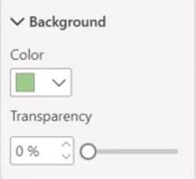
- You can also adjust the Font Style and Font Size of the data displayed in the tooltip to ensure the information is easily legible.

Shape Maps vs. Field Maps in Power BI:

Field Maps: Simplicity and Quick Insights
A field map allows you to display color-coded regions based on a metric, like sales, for predefined geographical areas. Here are some of the key features:
- Simplicity:
  - Field maps use predefined geographical boundaries from Power BI’s built-in mapping capabilities, making them easy to set up without the need for custom data.
  - They provide a quick and straightforward approach to map visualization.
- Quick Insights:
  - By using color gradients, field maps help you quickly assess data distribution and patterns across regions. For example, sales densities across countries or regions can be visualized efficiently.
- Bing Maps Integration:
  - Field maps integrate with Bing Maps, benefiting from its extensive geographic database. This ensures up-to-date and accurate boundary information, simplifying the creation of map visualizations without requiring specialized geographic datasets.
Shape Maps: Customization and Precision
A shape map, on the other hand, offers more flexibility, allowing users to import custom geographic data through vector files in TopoJSON format. These files store geographic data in a compact format, reducing data size and improving loading times. Here are the key features of shape maps:
- Customization:
  - Shape maps provide flexibility to create custom regions based on your unique geographical boundaries. This makes them ideal for scenarios like custom sales territories or nonstandard regions that aren’t covered by predefined maps.
- Precision:
  - Shape maps are great for representing nonstandard geographical boundaries, offering precise control over how your data is visualized, especially when specific custom-defined regions need to be displayed.
- Handling Data Complexity:
  - Shape maps excel at visualizing intricate or smaller regions, making them suitable for detailed analyses like customer distribution or granular sales territories.
Comparing Shape Maps and Field Maps
When deciding between shape maps and field maps, consider these four key differences:
- Data Source:
  - Shape Maps: Allow for importing custom geographic data, offering precise and detailed visualizations.
  - Field Maps: Use predefined geographical boundaries from Bing Maps, providing a more generalized view.
- Customization:
  - Shape Maps: Enable full customization of regions, ideal for scenarios like visualizing specific sales territories or administrative boundaries.
  - Field Maps: Offer limited customization but excel in providing quick insights into predefined regions.
- Data Representation:
  - Shape Maps: Associate values with custom regions, creating granular visualizations for complex territories.
  - Field Maps: Use color gradients to represent data within predefined regions, providing a high-level view of data distribution.
- Use Cases:
  - Shape Maps: Best suited for scenarios that require complex geographic representation, such as visualizing specific sales territories or detailed customer distribution.
  - Field Maps: Ideal for showcasing high-level patterns, like population densities, regional sales growth, or sales performance by country.
AdventureWorks Case Study: Choosing the Right Map
AdventureWorks faces a challenge. The company wants to showcase sales performance by country while highlighting regional sales growth. However, they also require a level of precision in visualizing specific trends.
- If AdventureWorks needs custom-defined regions or sales territories that are unique to the business, shape maps would be the ideal choice. Shape maps can accurately represent nonstandard regions, ensuring the precision needed for this task.
- On the other hand, if a more generalized view is acceptable, field maps provide a quicker and simpler solution. Field maps can easily display sales densities across various regions using color gradients, offering high-level insights without the need for custom data.

การเปรียบเทียบแผนที่รูปร่าง (Shape Maps) และแผนที่ข้อมูล (Field Maps) ใน Power BI

แผนที่ข้อมูล (Field Maps): ความง่ายและการมองเห็นข้อมูลอย่างรวดเร็ว
- ความง่าย: แผนที่ข้อมูลใช้ขอบเขตทางภูมิศาสตร์ที่กำหนดไว้ล่วงหน้าจากความสามารถในการทำแผนที่ในตัวของ Power BI ทำให้ตั้งค่าได้ง่ายโดยไม่จำเป็นต้องใช้ข้อมูลแบบกำหนดเอง
- การมองเห็นข้อมูลอย่างรวดเร็ว: แผนที่ข้อมูลใช้การไล่สีเพื่อช่วยให้คุณประเมินการกระจายและรูปแบบของข้อมูลได้อย่างรวดเร็วในแต่ละภูมิภาค ตัวอย่างเช่น การกระจายความหนาแน่นของยอดขายในแต่ละประเทศหรือภูมิภาคสามารถมองเห็นได้อย่างมีประสิทธิภาพ
- การผสานกับแผนที่ Bing: แผนที่ข้อมูลผสานกับแผนที่ Bing ซึ่งได้ประโยชน์จากฐานข้อมูลทางภูมิศาสตร์ที่ครอบคลุม ทำให้ข้อมูลขอบเขตเป็นปัจจุบันและแม่นยำ ทำให้การสร้างการมองเห็นแผนที่ง่ายขึ้นโดยไม่ต้องใช้ชุดข้อมูลทางภูมิศาสตร์เฉพาะทาง

แผนที่รูปร่าง (Shape Maps): การปรับแต่งและความแม่นยำ
- การปรับแต่ง: แผนที่รูปร่างให้ความยืดหยุ่นในการสร้างภูมิภาคแบบกำหนดเองตามขอบเขตทางภูมิศาสตร์ที่ไม่ซ้ำกันของคุณ ทำให้เหมาะสำหรับสถานการณ์ เช่น เขตการขายแบบกำหนดเองหรือภูมิภาคที่ไม่ได้มาตรฐานที่ไม่ได้ครอบคลุมโดยแผนที่ที่กำหนดไว้ล่วงหน้า
- ความแม่นยำ: แผนที่รูปร่างเหมาะสำหรับการแสดงขอบเขตทางภูมิศาสตร์ที่ไม่มาตรฐาน ให้การควบคุมที่แม่นยำเกี่ยวกับวิธีการมองเห็นข้อมูลของคุณ โดยเฉพาะอย่างยิ่งเมื่อจำเป็นต้องแสดงภูมิภาคเฉพาะที่กำหนดเอง
- การจัดการความซับซ้อนของข้อมูล: แผนที่รูปร่างมีความโดดเด่นในการมองเห็นภูมิภาคที่ซับซ้อนหรือเล็กกว่า ทำให้เหมาะสำหรับการวิเคราะห์เชิงลึก เช่น การกระจายลูกค้าหรือเขตการขายระดับละเอียด

การเปรียบเทียบแผนที่รูปร่างและแผนที่ข้อมูล
เมื่อตัดสินใจระหว่างแผนที่รูปร่างและแผนที่ข้อมูล ให้พิจารณาความแตกต่างที่สำคัญ 4 ประการนี้:
- แหล่งข้อมูล:
  - แผนที่รูปร่าง: อนุญาตให้นำเข้าข้อมูลทางภูมิศาสตร์แบบกำหนดเอง มอบการมองเห็นที่แม่นยำและละเอียด
  - แผนที่ข้อมูล: ใช้ขอบเขตทางภูมิศาสตร์ที่กำหนดไว้ล่วงหน้าจากแผนที่ Bing มอบมุมมองทั่วไป
- การปรับแต่ง:
  - แผนที่รูปร่าง: เปิดใช้งานการปรับแต่งภูมิภาคอย่างเต็มที่ เหมาะสำหรับสถานการณ์เช่นการมองเห็นเขตการขายเฉพาะหรือขอบเขตการบริหาร
  - แผนที่ข้อมูล: เสนอการปรับแต่งที่จำกัด แต่มีความโดดเด่นในการให้ข้อมูลเชิงลึกอย่างรวดเร็วในภูมิภาคที่กำหนดไว้ล่วงหน้า
- การแสดงข้อมูล:
  - แผนที่รูปร่าง: เชื่อมโยงค่ากับภูมิภาคแบบกำหนดเอง สร้างการมองเห็นระดับละเอียดสำหรับอาณาเขตที่ซับซ้อน
  - แผนที่ข้อมูล: ใช้การไล่สีเพื่อแสดงข้อมูลภายในภูมิภาคที่กำหนดไว้ล่วงหน้า มอบมุมมองระดับสูงของการกระจายข้อมูล
- กรณีการใช้งาน:
  - แผนที่รูปร่าง: เหมาะที่สุดสำหรับสถานการณ์ที่ต้องการการแสดงทางภูมิศาสตร์ที่ซับซ้อน เช่น การมองเห็นเขตการขายเฉพาะหรือการกระจายลูกค้าเชิงละเอียด
  - แผนที่ข้อมูล: เหมาะสำหรับการแสดงรูปแบบระดับสูง เช่น ความหนาแน่นของประชากร การเติบโตของยอดขายในภูมิภาค หรือประสิทธิภาพการขายตามประเทศ

Power BI Azure maps
Azure Maps is part of the broader Azure Location-Based Services (LBS) platform, offering capabilities such as mapping, searching, routing, and traffic services. The Azure Maps visual in Power BI connects to a cloud service hosted in Azure to retrieve geospatial data, rendering detailed and interactive map visuals.
Advantages of Azure Maps in Power BI
- Seamless Integration with Azure Services: Connect with other Azure services for advanced functionality.
- Advanced Geospatial Features: Such as geocoding, which retrieves map coordinates from location data (e.g., latitude and longitude).
- Scalability and Performance: Efficient data handling for large datasets.
- Enterprise-Grade Security: Built-in security and data compliance features.
- Developer Friendliness: Customization and extensibility through Azure APIs.
Use Case: Competitor Analysis by State for AdventureWorks
As a data analyst at AdventureWorks, you have access to public sales report data from a competitor. Your task is to configure an Azure Map to analyze competitor data by state, visualizing the number of resellers in each region.
Step-by-Step Guide to Configuring Azure Maps in Power BI
1. Enable Azure Maps in Power BI
- Launch Power BI and open your report.
- In the Visualizations pane, click on the Azure Maps icon.
- A disclaimer will appear regarding Azure Maps’ use of data. Review and proceed.

2. Access the Data Model
- Switch to the Model View to examine the underlying data model.
  - You will work with three tables: Reseller Sales Fact, Geography, and Reseller Dimension.
  - Ensure that these tables are related by one-to-many relationships for accurate analysis.
3. Configure the Azure Map Visual
- Return to the Report View.
- Drag the Country field from the Geography table into the Location well of the Azure Maps visual. This will map the locations based on countries.
- Drag the Reseller measure from the Reseller Dimension table into the Size well. This adjusts the size of bubbles proportionally to represent the number of resellers in each region.
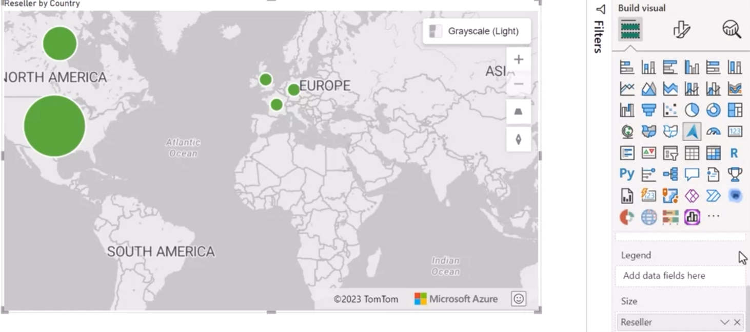
4. Add Color-Coding by Product Line
- To analyze resellers by product line, drag the Product Line field from the Reseller Dimension table into the Legend well.
  - This will color-code the bubbles based on different product lines, giving a visual breakdown of reseller distribution.
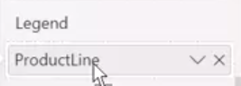
5. Format the Map Visual
Next, let’s explore formatting options to enhance the map's appearance and usability:
- Map Style:
  - Go to Visualizations > Format Visual > Visual > Map Settings.
  - In the Style dropdown, select Road to display a basic road map.
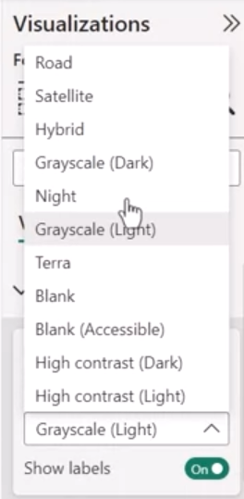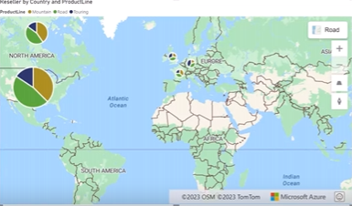
- Bubble Layer:
  - Under the Bubble Layer section, configure the bubbles:
    - Set the Bubble size to 15 pixels for better visibility.
    - Adjust Bubble colors based on product lines to differentiate between resellers.
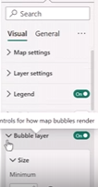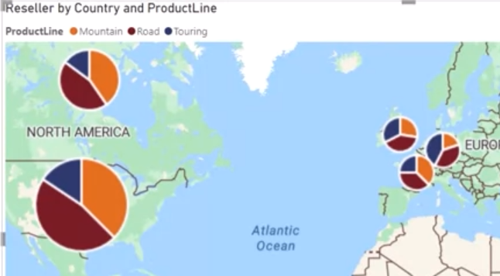
- Accessibility:
  - Add Category labels to each bubble, and set the Font size to 12 for clarity.
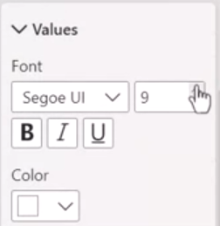
  - Reduce Transparency to 25% for a clearer view of data on the map.
  - 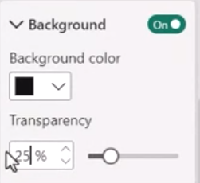

6. Customize the Map Title and Appearance
- Go to Format Visual > General to configure the Title and its formatting options:
  - Change the map title to a descriptive one like Competitor Reseller Analysis by State.
  - Adjust the title’s color, font size, and style to align with your report’s design.
7. Final Review and Insights
You’ve now configured the Azure Map to visualize competitor resellers across different countries, broken down by product line. This map provides critical insights into reseller distribution and product performance across regions, enabling AdventureWorks to better understand its competitive landscape.

Custom Visualizations
AdventureWorks needs a custom visualization to explore its sales data in ways that existing visuals can’t accommodate. In this lesson, you will learn how to build custom visuals in Power BI using Python.

What Are Custom Visualizations?
Custom visualizations are user-defined visual elements that enhance data analysis by catering to specific needs. They provide insights beyond what standard visuals offer, helping organizations uncover trends and patterns within their data that might otherwise go unnoticed. For example, through custom visuals, AdventureWorks may discover seasonal trends, like an increase in bicycle repair equipment sales during winter months.

Why Custom Visualizations Matter
- Address Unique Analytical Needs: Every organization faces different challenges. Custom visuals can be designed to reflect AdventureWorks' specific sales patterns or business dynamics.
- Enhanced Data Storytelling: Tailored visuals help communicate data insights more clearly and effectively than generic visuals might.

Sources of Custom Visuals in Power BI
You can install custom visuals in Power BI from various sources:
- Power BI Marketplace: A library of custom visuals created by developers.
- AppSource: Certified visuals developed by Microsoft and its partners.
- Python or R Programming: Create fully customized visuals using these programming languages.

Using Python for Custom Visualizations
Python is a powerful, beginner-friendly, open-source programming language widely used for data analytics. With rich libraries like Matplotlib and Seaborn, it provides excellent tools for creating sophisticated visualizations.
If you're familiar with Python or want to expand your skillset, it’s worth exploring how to create custom Power BI visuals using Python.

Setting Up Python in Power BI
Before building your custom visual, you need to configure Python in Power BI. Let’s walk through the process:

1. Enable Python Scripting in Power BI
- Open Power BI Desktop.
- Navigate to File > Options and Settings > Options.
- Select Python Scripting under the Global section.
- Ensure Power BI detects the Python home directory (installation path). If not, manually paste the path from your Python installation.
- Click OK.
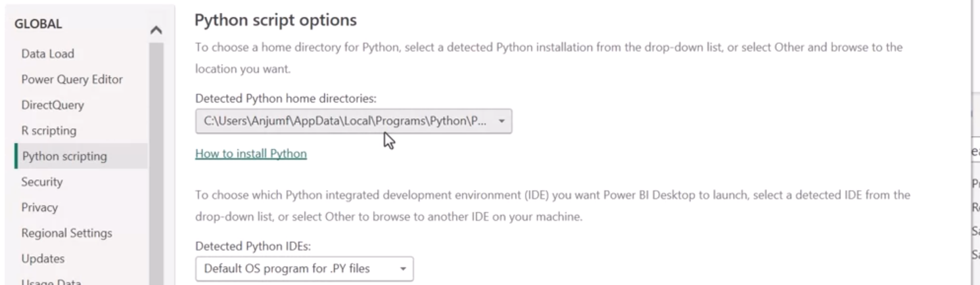

2. Import Data Using Python in Power BI
Python in Power BI serves two main purposes:
- Importing data.
- Creating custom visualizations.
Let’s start by importing a dataset using Python:
- Navigate to the Home tab in Power BI and select Get Data.
- In the dropdown menu, select More to open the Get Data dialog box.
- In the search bar, type "Python" and choose Python Script from the list.
- Click Connect.
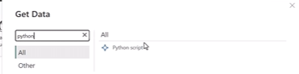
A Python Script dialog box will appear. Here, you can write your Python code to import data.

3. Write a Python Script to Import Data
To import data, write a Python script that uses pandas, a powerful data manipulation library in Python.
For example:
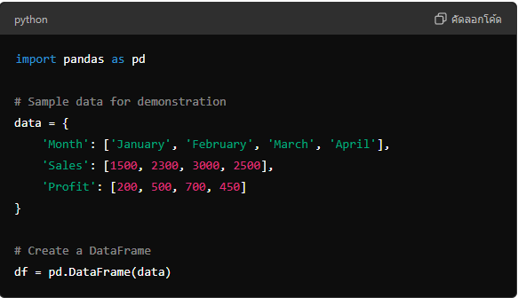
This script creates a DataFrame named df containing sample data with columns for Month, Sales, and Profit.

4. Load the Dataset into Power BI
Once the script runs, Power BI will open a Navigator window displaying the dataset. Click Load to import the dataset into Power BI, and it will appear in the Data pane.
You can now use this dataset for custom visualizations.

Creating a Custom Visualization in Power BI Using Python
Now that we have the data, let’s create a custom visualization. You can use Python Visuals to render custom plots.

1. Add a Python Visual to the Report
- In the Visualizations pane, click on the Python visual icon.
- A placeholder will appear in your report, and a Python script editor will open at the bottom of the page.

2. Write the Visualization Code
Using Matplotlib or Seaborn, you can generate a custom visual. For example, let’s create a line chart showing sales over time:
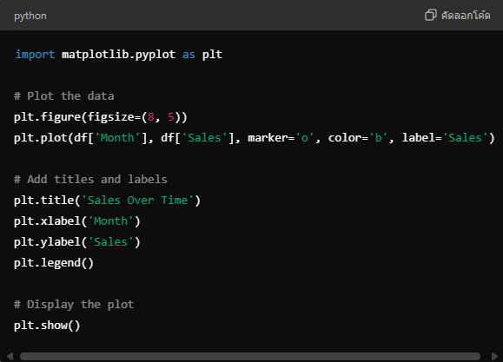
This script creates a line chart visualizing sales for each month.

3. Run the Script
- Click Run to generate the visual in Power BI.
- The Sales Over Time chart will render in the Python visual placeholder.

Final Thoughts: Power of Python in Power BI
Custom visualizations using Python provide unique advantages:
- Flexibility: Create visuals not available in Power BI’s default selection.
- Advanced Analytics: Leverage Python’s extensive libraries for deep analysis, from machine learning to custom data manipulation.
- Enhanced Reporting: Tailored visuals improve clarity and provide more actionable insights.
By integrating Python with Power BI, you unlock a powerful combination of business intelligence and data science.

External Python libraries may introduce security risks. It is, therefore, essential to be aware of this and use only the Python libraries from trusted data sources.
Introduction: Unlocking Advanced Analytics
As a data analyst, it's essential to extract meaningful insights from your data and present them in a compelling manner. Power BI's integration with Python allows you to perform deeper data exploration and create sophisticated custom visualizations that go beyond the built-in visuals.
AdventureWorks is facing a similar challenge: their sales data requires more advanced visuals than what Power BI offers by default. In this guide, you’ll learn how to leverage Python to create custom visualizations in Power BI, providing AdventureWorks with a more comprehensive analysis of their datasets.
Why Use Python for Power BI Visuals?
Python is a versatile scripting language with powerful libraries like Matplotlib and Seaborn that enable the creation of dynamic and intricate visualizations. Integrating Python into Power BI expands your visualization options, allowing for:
- Advanced analytical insights beyond built-in Power BI visuals.
- Customized data representations suited to your organization's unique needs.
While Python enhances Power BI’s capabilities, there are a few important limitations to note:
- Dataset size: Python visuals are limited to 150,000 rows.
- Input limits: Python can handle up to 250 MB of data.
- Performance: Python visuals refresh with every data update, filter, or highlight.
- Security concerns: External Python scripts may pose security risks.
Python visuals respond when elements in other Microsoft Power BI core visuals are selected. However, this is not true in the other direction, You cannot select elements in the Python visual to cross-filter other elements of the report.
If the data tables are not connected by relationships in the data model, you will get an error in the Python visualization.
You can import any custom visual from AppSource and use it to create a chart in a Microsoft Power BI report. When you then publish the report to the Microsoft Power BI Service, the custom visual functionality will not be impacted and can be viewed by anyone who has been given access to the published report.
Getting Started: Integrating Python in Power BI
Step 1: Install Python and Required Libraries
Before starting, ensure that Python is installed on your system. You’ll also need to install visualization libraries like Matplotlib and Seaborn:
pip install matplotlib seaborn pandas
Step 2: Enable Python Scripting in Power BI
- Open Power BI Desktop.
- Navigate to File > Options and Settings > Options.
- In the Global section, select Python scripting.
- Ensure Power BI detects the correct Python installation path.
- Click OK.
Step 3: Create Your First Python Visual in Power BI
We’ll start with a simple example using a sample dataset to demonstrate how to create a custom Python visualization.
- In the Visualizations pane, select the Python visual icon.
- A prompt will appear asking to enable script visuals. Click Enable.
- A placeholder for the Python visual appears on the report canvas, and a Python script editor opens at the bottom of the page.
Power BI automatically generates Python code based on the fields you drag into the Values section. Let’s create a scatter plot using a sample dataset.
- Add data to the Values section by dragging fields (e.g., Age and Weight) into the Python visual.
- Power BI generates a DataFrame named dataset that you can manipulate in the Python script editor.
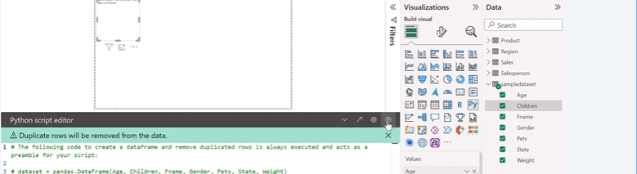
Step 4: Write a Python Script for the Scatter Plot
In the Python script editor, use Matplotlib to create the scatter plot:

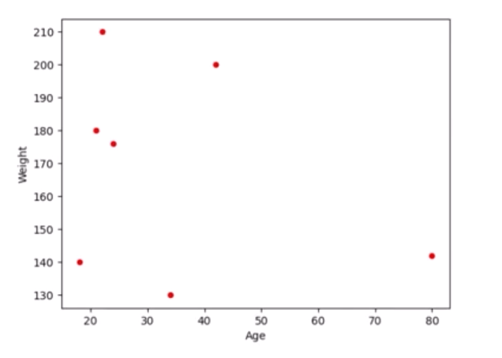

Creating a Custom Visualization for AdventureWorks
Now, let’s build a more relevant visualization using AdventureWorks’ sales data. The goal is to create a bar chart showing total sales by country.
Step 1: Load the AdventureWorks Sales Data
In the AdventureWorks Sales Power BI project, you have four related tables:
- Sales
- Products
- Salesperson
- Region
Ensure that the relationships between these tables are correctly defined. Without these relationships, you cannot use fields from different tables in Python visuals.
Step 2: Set Up the Python Visual
- Add a Python visual to the canvas from the Visualizations pane.
- Drag the following fields to the Values section:
  - Total Sales from the Sales table.
  - Country from the Region table.
Power BI will generate a DataFrame named dataset, grouping the fields and removing any duplicate rows.
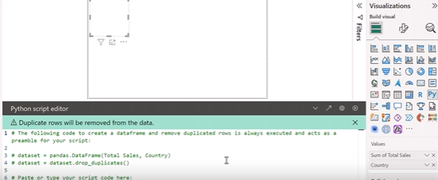

Step 3: Write a Python Script for the Bar Chart
Now, let’s create a bar chart showing total sales per country using Matplotlib.

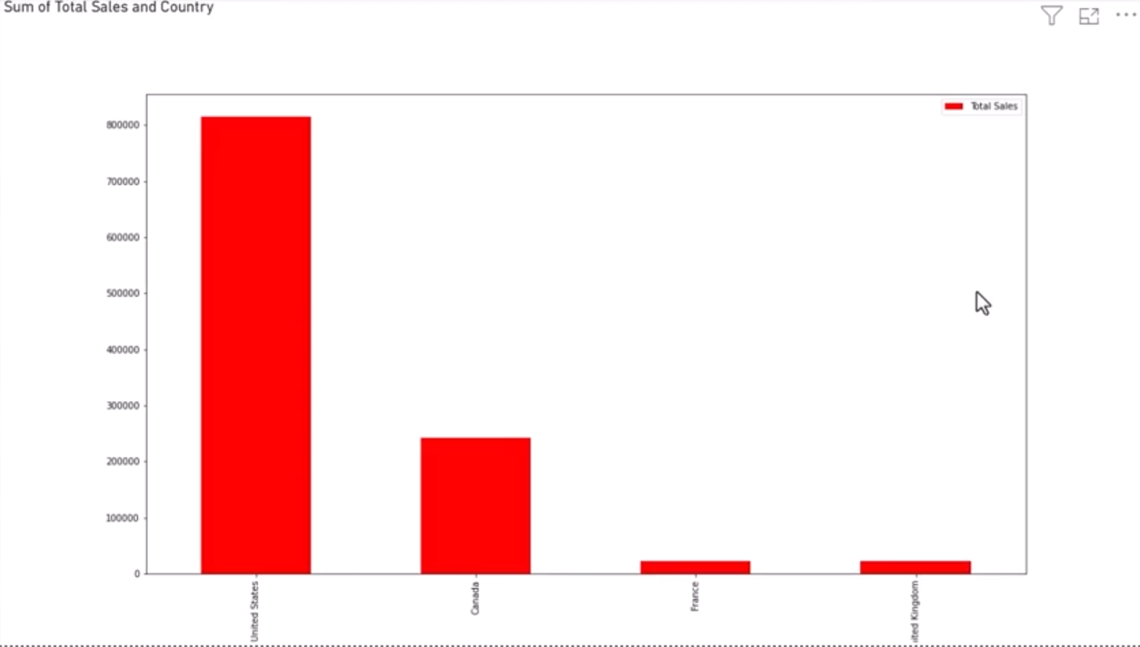
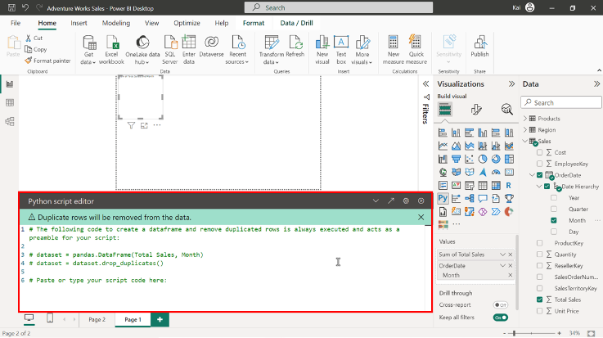
import matplotlib.pyplot as plt
ax = plt.gca()
dataset.plot(kind = ‘bar’ , x= ‘Month’, y= ‘Total Sales’, ax=ax)
plt.show()
dataset.plot(kind = ‘bar’ , x= ‘Month’, y= ‘Total Sales’, color = ‘red’, ax=ax)
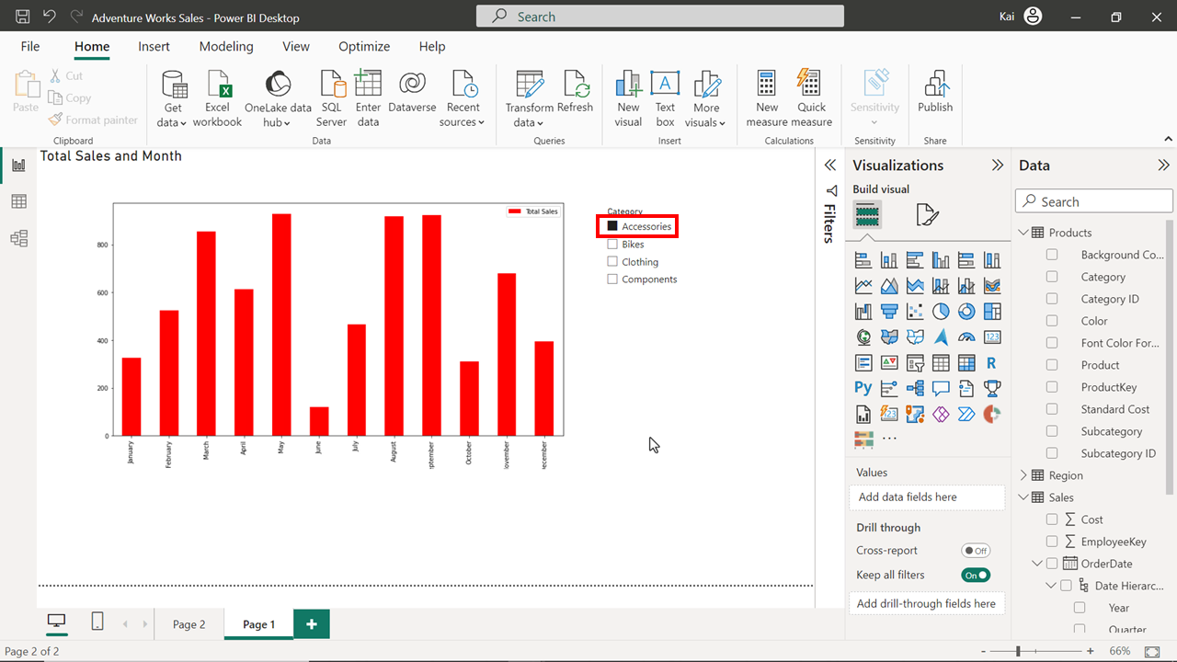
- Prerequisites for using Python-based visualizations in Microsoft Power BI:
- Ensure that Python scripting is configured in Microsoft Power BI desktop.
- Install Python on your local computer.
- Import the Python visualization libraries.
- In a Microsoft Power BI core KPI visual, the chart automatically plotted when you add the main measure and trend axis is: Area chart
- Advantages of a Dot plot over other visualizations for comparing data points:
- Its simplicity and ease of interpretation
- Its ability to use categorical information on the horizontal axis
- For a complex dataset with multiple numerical fields to uncover correlations, patterns, and insights: Scatter chart
- Accessibility features to include in a Power BI report:
- Provide appropriate chart and axis titles.
- Apply an accessibility theme.
- Use tab orders from the selection pane.
- For visualizing air quality, temperature variations, and pollution levels in various regions: Filled maps
- Typical use case scenarios for a Filled map visual in Microsoft Power BI:
- Displaying an overview of geographical distribution.
- Displaying quantitative information on map.
- For analyzing the number of franchises in various regions and associated sales amounts in a multi-national retail organization: Azure maps
- True or False: You must format the color scheme of a Python-created Bar chart from the Format visual tab in Power BI. False (Python visualizations are rendered as images and cannot be formatted through Power BI's interface)
- To highlight which areas of a website receive the most and least clicks: Heatmap

Module 3 : Dashboard design and storytelling

Improving Dashboard Design
Dashboards:
- Purpose: Provide a high-level overview of key metrics and performance indicators.
- Design: Concise, focused on essential information, visually appealing, and mobile-responsive.
- Elements: Executive summary, sales performance, market overview, customer metrics, operational performance, strategic initiatives.
Reports:
- Purpose: Offer in-depth analysis and exploration of granular data.
- Design: Detailed, structured, interactive, and storytelling-oriented.
- Elements: Layout and structure, interactivity (slicers, filters, drill-down/drill-through), storytelling (text boxes, annotations, narratives).
Key Differences:
- Level of detail: Dashboards provide a high-level overview, while reports offer detailed insights.
- Purpose: Dashboards are for quick decision-making and monitoring, while reports are for in-depth analysis and exploration.
- Design: Dashboards are concise and visually appealing, while reports are more detailed and structured.
- Interactivity: Reports offer more interactive features like slicers, filters, and drill-down/drill-through.
Use Cases:
- CEO: Dashboard with high-level insights and KPIs.
- Sales Director: Report with drill-down and drill-through features for detailed analysis.
- Marketing Director: Report with focus on marketing channels, campaign performance, and customer segmentation.

1. Understanding Your Audience
- Identify End Users: Determine who will be interacting with the dashboard (e.g., sales, marketing, or finance teams).
- Define User Needs: Work closely with user groups to understand their specific data requirements and objectives.
- Assess Data Literacy: Tailor dashboards based on how familiar users are with data. For instance, sales teams may need simple visuals, while finance teams may require more complex charts.
- Consider Device Preferences: Optimize dashboards for the devices users typically access, whether on desktops, tablets, or mobile devices.
2. Designing the Dashboard
- Prioritize Key Metrics: Place critical information (KPIs) at the top of the dashboard. Key performance indicators like revenue, units sold, and profit should be highlighted.
- Logical Layout: Organize trends, performance comparisons, and general information in a clear hierarchy from top to bottom.
- Consistency in Design: Maintain uniformity in colors, fonts, and styles throughout the dashboard. Use consistent colors for positive and negative values across all visuals.
- Choose Appropriate Visuals: Select visuals like bar charts, line charts, or custom visuals that best convey the data story. Avoid clutter or overly complex visuals that might confuse users.
- Responsive Design: Ensure that the dashboard works well across all screen sizes, especially mobile devices.
- Create a Narrative Flow: Use text boxes, card visuals, and annotations to guide users through the data, providing context where necessary.
3. Testing and Feedback
- After designing the dashboard, it's crucial to test it with users and gather feedback. This step allows for refining the design to ensure it meets the user's needs and preferences.
4. Examples of User-Specific Dashboards
- Sales Dashboard: Focuses on sales performance, key metrics, and trends, making it relevant and understandable for sales managers.
- Marketing Dashboard: Monitors campaign effectiveness, social media engagement, demographic insights, and competitor analysis.
- Customer Support Dashboard: Tracks support tickets, displays satisfaction scores, and provides a real-time view of open tickets and common issues.

Importance of Mobile Optimization:
- Accessibility: Ensure dashboards are accessible to users who rely on smartphones.
- Real-time decision making: Provide up-to-date information for strategic decisions on the go.
- Enhanced user experience: Improve the ease of interaction and understanding of data.
Optimizing the AdventureWorks Sales Dashboard:
- Open the dashboard: In Power BI service, select the Sales Summary dashboard.
- Switch to mobile layout: Select "Edit" -> "Mobile layout."
- Rearrange and resize tiles: Drag and drop tiles to the desired position and size.
- Unpin tiles: Remove unnecessary tiles from the mobile view.
- Save changes: The mobile layout is automatically saved.

Additional Dashboard Elements
Managing multiple dashboards in Power BI efficiently is key to handling large data sets and catering to different audiences. When you need to design multiple but similar dashboards, such as for managers in different regions, manually creating each one from scratch is inefficient. Instead, Power BI provides features to help streamline this process. Here's a breakdown of the two main approaches to accelerate your workflow:
1. Duplicating Dashboards
Duplicating an existing dashboard can save time and effort in the following scenarios:
- Using Dashboards as Templates: When creating dashboards for similar use cases, such as for different regions or departments, you can use an existing dashboard as a template. Build the first dashboard, duplicate it, and then modify the copy as needed to reflect the unique data of the second use case.
- Testing Dashboards: If you need to test different designs or performance between two dashboards, duplicating one and adjusting the copy can help you compare the results side by side.
- Creating Regional Versions: For global operations, you may need to create versions of a dashboard that differ slightly to match local languages, cultures, or other regional needs.
- Same Data Structures: When new databases have the same structure as the original, you can duplicate a dashboard and adapt it to the new dataset.
Steps to Duplicate a Dashboard:
- Open Power BI service.
- Select the dashboard you want to copy from My Workspace.
- Navigate to File and select Save a Copy.
- Name the duplicate dashboard and make necessary changes, such as adding or resizing tiles.
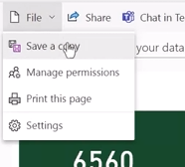
2. Pinning Visual Elements from One Dashboard to Another
If you need to reuse specific visuals from one dashboard in another, pinning tiles between dashboards allows you to efficiently reuse content without rebuilding it. When you pin a tile:
- The visual is linked to the original report, meaning any updates made to the original data will automatically be reflected in all dashboards where that tile is pinned.
- This method is useful when you want to include frequently updated visuals across different dashboards but don’t want to manually update each one.
Steps to Pin a Tile to Another Dashboard:
- Open the dashboard containing the visual you want to pin.
- Hover over the tile and select More options (three dots).
- Choose Pin tile and select either an existing dashboard or create a new one.
- The visual will now be available in the selected dashboard.
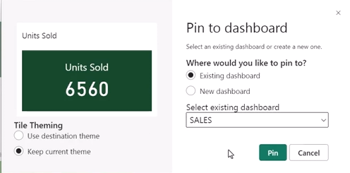

Key Considerations:
- Power BI Service Only: You must use Power BI Service to duplicate dashboards and pin visuals; these features are not available in Power BI Desktop.
- Permissions: You can only duplicate dashboards and pin tiles from dashboards you’ve created. Dashboards shared with you do not have these capabilities unless you are the owner.
- Customization: Once a dashboard is duplicated, you can resize, rename, delete tiles, and pin new ones to match your specific requirements.
Use Cases:
- Global Sales Dashboards: For example, a global sales director might need regional sales dashboards. Instead of creating separate dashboards from scratch for each country, you could duplicate a global sales dashboard and tweak it for each region’s data.
- Cross-Departmental Dashboards: You might have a visual that shows company-wide KPIs, and you want to display this across multiple departmental dashboards without rebuilding the visual each time. Pinning that KPI visual ensures consistency across all dashboards.

Dashboards and Media
Incorporating media elements into Power BI dashboards is a powerful way to enhance user engagement, provide better context, and improve data-driven decision-making. Here’s a summary of the key points about using media and real-time data streaming in Power BI dashboards:
Media Elements in Power BI Dashboards
Power BI Service allows the integration of various media types to create visually engaging and informative dashboards. These include:
- Text Boxes: Useful for adding explanatory notes, titles, or instructions.
- Images: Help reinforce branding or add visual context, such as company logos, product photos, or maps.
- Videos and Animations: Add depth to the data, such as promotional clips or manufacturing process videos, enhancing storytelling.
- Web Content: Allows embedding of interactive web elements, improving user experience.
- Live Streaming Data: Real-time data updates enable you to track rapidly changing metrics directly on your dashboard.
Benefits of Using Media in Power BI Dashboards
- Context Enhancement: Images and videos provide a clearer understanding of the data, adding meaning to charts and graphs.
- Improved Engagement: Visually attractive dashboards are more engaging and help capture the audience’s attention.
- Brand Reinforcement: Logos and other branded visuals maintain consistency and reinforce the organization’s identity.
- Instructional Assistance: Short video tutorials or animations can guide users on how to navigate and interact with the dashboard.
- Summary and Focus: Icons or images can serve as quick visual cues to summarize key data insights, making them easier to interpret.

Real-Time Data Streaming in Power BI
Real-time data streaming enables users to display and monitor up-to-the-minute information, which is particularly useful in situations where decisions depend on constantly updated data. Power BI supports three types of real-time datasets:
- Push Datasets:
  - Data is pushed from an external source (e.g., SQL Server) and stored in Power BI.
  - You can create standard reports, visuals, and dashboard tiles that update in real time when the underlying data changes.
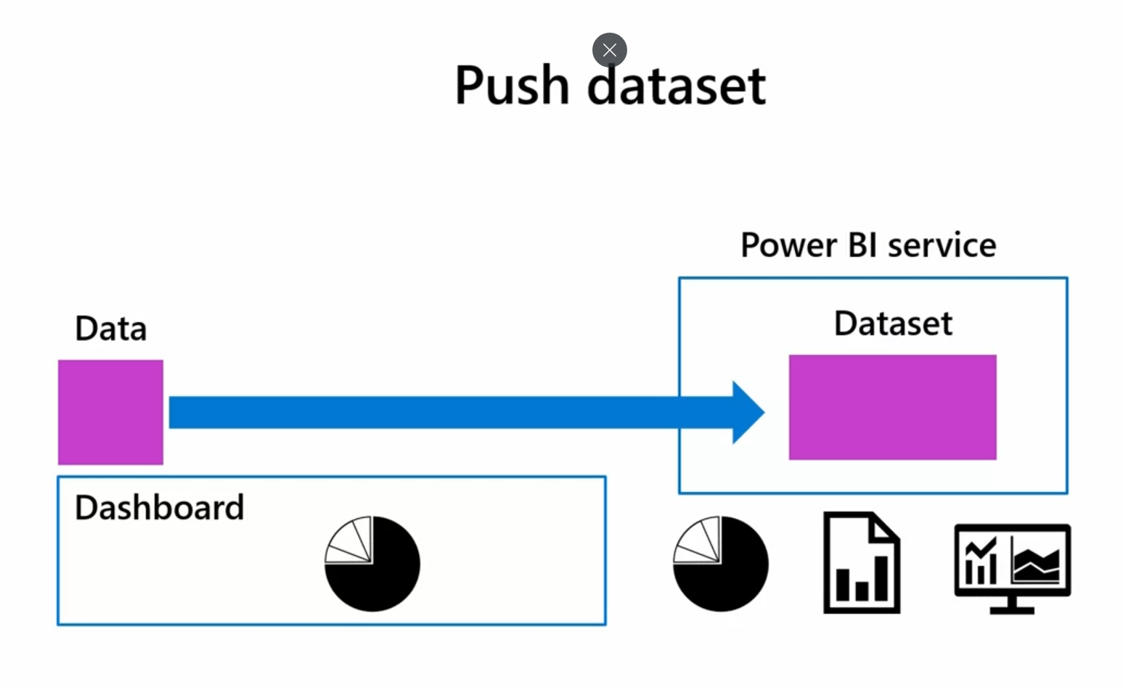
- Streaming Datasets:
  - Streaming data is pushed from external systems (e.g., Amazon Web Services, Oracle) to Power BI, but is not stored in Power BI memory.
  - You can only create live data visualizations directly on dashboard tiles (not standard reports).

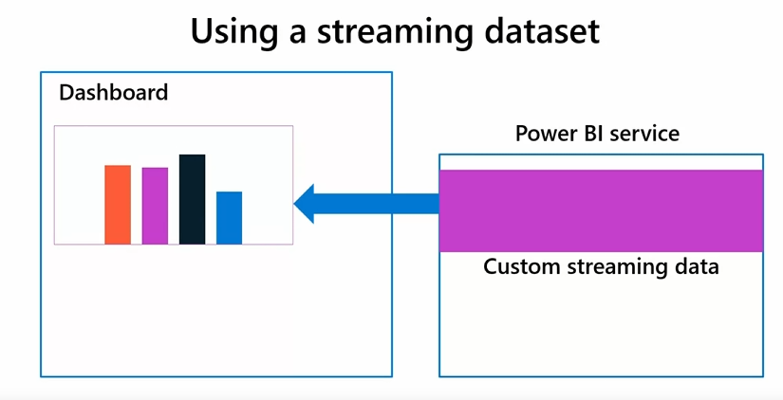
- PubNub Streaming Datasets:
  - PubNub is a platform for building real-time applications with low-latency data streaming.
  - Power BI directly reads and displays PubNub data streams without storing any data.
  - PubNub is scalable and secure, making it suitable for applications with large or distributed audiences.
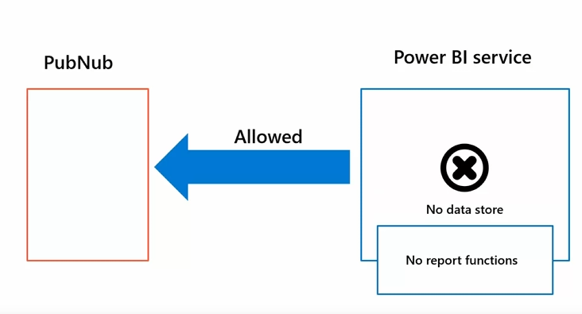

Advantages of Real-Time Data in Dashboards
- Up-to-Date Metrics: Dashboards can display the latest data, essential for real-time monitoring (e.g., sensors, social media metrics).
- Quick Response to Changes: Teams can react quickly to operational disruptions or market trends by analyzing live data.
- Alerts and Notifications: Dashboards can include alert mechanisms that notify users when specific conditions are met, improving responsiveness.
- Enhanced Collaboration: Real-time data enables teams to make informed decisions and adjustments collaboratively in real time.

Choosing a Streaming Method
When deciding between push datasets, streaming datasets, or PubNub streaming, consider:
- Data Hosting Location: Whether the data is stored locally (push dataset) or streamed directly from external services (streaming and PubNub datasets).
- Analytical Needs: Push datasets allow full reporting capabilities, while streaming and PubNub datasets are limited to tile-based visuals.
- Infrastructure Availability: PubNub may be preferred for large-scale, low-latency applications due to its scalability and global reach.

Types of Media Elements:
- Text boxes: For adding headings, descriptions, and other text content.
- Still images: For incorporating logos, charts, and other static visuals.
- Video clips: For embedding videos from YouTube or Vimeo.
Adding Media Elements:
- Select "Add a tile" from the edit dropdown.
- Choose the desired media type (text box, image, or video).
- Enter the required information (title, description, URL, etc.).
- Customize the appearance and formatting of the tile.
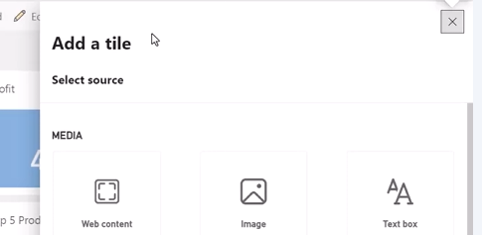
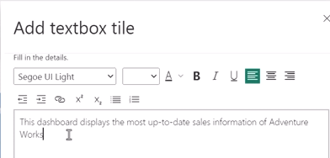
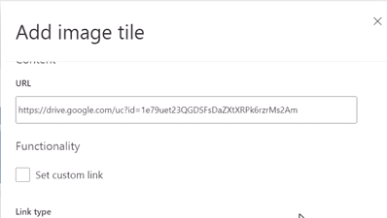
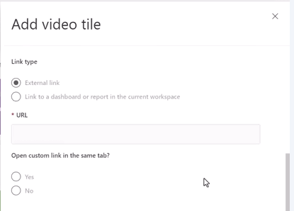

Formatting Media Elements:
- Text boxes: Adjust font size, color, indentation, and alignment.
- Images: Resize, reposition, and add custom links.
- Videos: Display title and subtitle, set custom links, and choose playback options.

QR codes in dashboards
What is a QR Code?
A QR code (Quick Response code) is a two-dimensional barcode that can store various types of information, such as:
- URLs
- Text
- Contact details
- Phone numbers
When users scan the QR code with their mobile devices, they can instantly access the associated content, making it easier and faster for them to interact with the dashboard or report.
Benefits of Using QR Codes in Power BI
- Improved Access: QR codes simplify data access by allowing users to scan the code rather than typing in URLs, making it convenient to access critical information quickly.
- Enhanced User Experience: Mobile-friendly QR codes allow users to access data wherever they are, aligning with the trend of mobile business intelligence.
- Increased Engagement: They can be used to link to external resources, marketing materials, or surveys, making the dashboard more interactive.
- Real-Time Data: As data in a dashboard tile or report is updated, the QR code automatically links to the most recent version, ensuring users always get the latest information.
- Easy Sharing: QR codes can be shared with teams or stakeholders, making it easier for multiple users to access and engage with important metrics and reports.
How to Generate a QR Code in Power BI
- For a Dashboard Tile:
  - Log into Power BI Service and open your Sales Summary Dashboard.
  - Choose the tile you want to generate the QR code for (e.g., "Sales by Salesperson").
  - Click on the three dots (More Options) in the top-right corner of the tile and select Open in Focus Mode.
  - In Focus Mode, click the More Options again and select Generate QR Code.
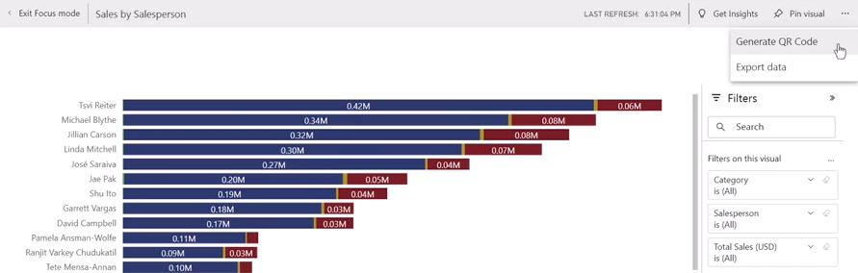
  - A dialog box will appear with the QR code. You can:
    - Scan the code with your mobile device to directly access the data.
    - Download the QR code as an image, which can be shared via email or printed and displayed in public spaces.
- For an Entire Power BI Report:
  - Open the AdventureWorks Report from your My Workspace in Power BI Service.
  - Go to File and select Generate QR Code from the drop-down.
  - A QR code for the entire report will be generated, which can be scanned or shared similarly to a tile QR code.
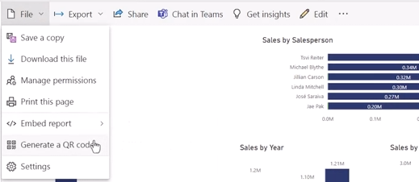
Using the QR Code
- The Power BI Mobile App allows users to scan the QR code and directly access the report or dashboard tile, providing a seamless and mobile-friendly experience.
- QR codes can be shared with marketing teams to link sales reports with promotional materials or used to gather user feedback or track campaign performance.
Best Practices for Printing QR Codes
- Ensure the QR code is printed at 100% size to maintain scan accuracy.
- Display the QR code in easily accessible locations (e.g., office spaces, marketing materials).

Principles of Data Storytelling
Data storytelling is a vital skill for transforming raw data into meaningful, engaging narratives that drive insights and decision-making. Like starting a film halfway through, presenting a report or dashboard without a clear story can confuse your audience, making it difficult for them to follow the insights. In large organizations like Adventure Works, where employees and stakeholders are spread across different regions, effective data storytelling is essential to ensure that everyone understands the data and can act on it.
Key Components of Data Storytelling
Effective data storytelling relies on three main components:
- Data:
Data forms the foundation of the story, representing the raw facts, statistics, and insights that you want to communicate. Using tools like Microsoft Power BI, data can be processed, analyzed, and presented in a way that provides context for your audience. The goal is to identify the main message the data conveys and use it as the basis for the narrative.
- Narrative:
The narrative is the structure that guides your audience through the data. It adds meaning and context to the data by explaining key findings and their significance. A well-crafted narrative:
  - Presents a clear beginning, middle, and end.
  - Outlines key data points.
  - Interprets the data to show its implications and significance. By walking the audience through these steps, the narrative helps people understand complex insights, even if they are not technically proficient.
- Data Visualization:
Visual elements, like charts, graphs, and maps, are critical in helping viewers quickly grasp the insights from the data. Visualizations bring data to life by:
  - Highlighting trends and patterns.
  - Making raw data more accessible.
  - Complementing the narrative by reinforcing the key message. Effective visualizations can take complex datasets and make them easy to digest, allowing audiences to engage with the data more effectively.

How These Components Work Together
Data, narrative, and visualizations must be seamlessly integrated. Together, they create a cohesive and compelling data story. Each component enhances the other:
- Data provides the evidence and context.
- The narrative gives structure and meaning.
- Visualizations help the audience quickly grasp and understand the data’s insights.
This combination can evoke an emotional response, driving engagement and making the data more memorable.
Benefits of Data Storytelling
- Engagement:
Engaging stories capture attention. This is crucial for presenting important data to stakeholders, ensuring they focus on the message you're trying to convey.
- Enhanced Understanding:
Data storytelling simplifies complex data, making insights accessible to a broader audience, even those without a deep technical background. Visualization and narrative highlight key points, making them easier to understand.
- Improved Communication:
Data storytelling facilitates communication across departments. It allows data analysts and non-technical teams to collaborate, improving the flow of insights and ideas within an organization.
- Problem Solving:
Data stories reveal patterns and trends that might not be apparent in raw data, helping organizations identify problems and opportunities. This proactive approach supports better business decisions.
- Effective Reporting:
In any field—whether research, business, or academia—data storytelling enhances the quality of reports and presentations. It transforms what could be dry data into engaging, informative narratives that capture the audience's attention.

Storytelling Elements:
- Setting: The context and background of the data story, including data sources, timeframe, and broader context.
- Characters: The individuals involved in the analytical process, such as data analysts, stakeholders, and business leaders.
- Conflict: The business problem or data challenge that needs to be resolved.
- Resolution: The insights, findings, and actionable recommendations derived from the analysis.
Example: AdventureWorks Data Story:
- Setting: Declining sales of AdventureWorks products.
- Characters: Data analyst, AdventureWorks CEO, stakeholders.
- Conflict: Identifying the reasons for declining sales and devising strategies to reverse the trend.
- Resolution: Insights into product performance, customer feedback, and marketing efforts, leading to targeted marketing campaigns and increased sales.

Data storytelling process
1. Goal and Hypothesis:
- Define a clear goal and hypothesis for your analysis.
- Understand the message or insight you want to convey.
2. Data Collection and Preparation:
- Collect data from relevant sources.
- Clean, transform, and prepare the data for analysis.
- Ensure the data is well-structured and aligns with your story's goal.
3. Data Analysis and Exploration:
- Use statistical analysis, hypothesis testing, and data exploration techniques.
- Identify key insights, trends, correlations, and anomalies.
4. Data Visualization:
- Choose appropriate chart types to represent your data effectively.
- Create visualizations that reveal patterns, trends, and findings.
- Use visualizations to provide context, interpret results, and articulate insights.
- Create a dashboard in Power BI to present your findings in a single canvas.
5. Audience Consideration:
- Tailor your story to your audience's background, knowledge, and needs.
- Design a narrative that resonates with your audience.
6. Communication:
- Use dynamic and engaging communication methods, such as presentations, interactive reports, and dashboards.
- Collect feedback from stakeholders to refine your storytelling approach.
7. Feedback and Iterations:
- Gather feedback from team members and stakeholders.
- Iterate on your story based on feedback to improve its effectiveness.

8. Actions and Decision-Making:
- Link the story back to the actions and decisions that need to be taken.
- Motivate stakeholders to make informed decisions based on the data-driven insights.
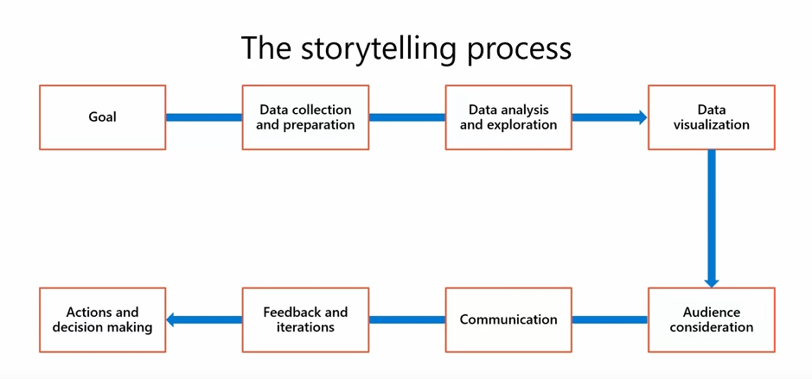

Examples of poor storytelling

Example 1: Chaotic canvas
A cluttered Power BI dashboard is the most common example of ineffective storytelling. When the Power Bi canvas is overloaded with graphs, charts, and widgets, it becomes challenging to interpret the key message. The end users of the story are bombarded with too much information, leading to confusion rather than clarity.

This issue typically arises due to a lack of visual hierarchy and focus. Effective storytelling requires a thoughtful layout design. The dashboard should be a clear reflection of the story you are telling. An effective dashboard will guide the viewers’ eyes along the flow of the story with coherence and simplicity.
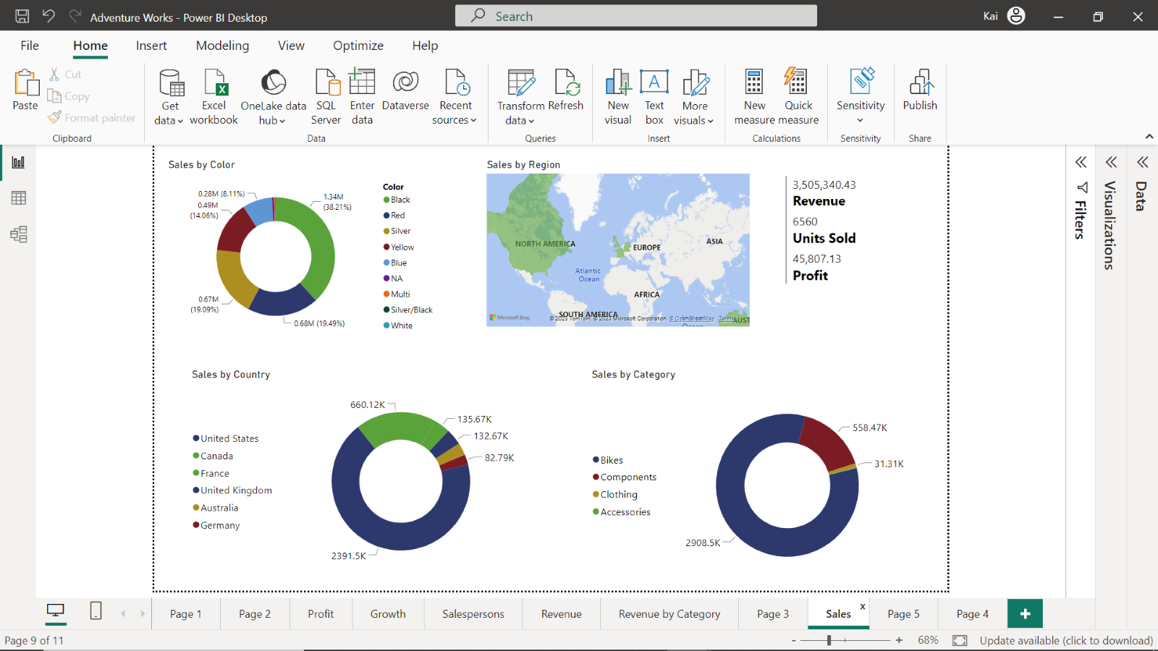
In this sales dashboard, there is no logical sequence to the visuals presented. The overall canvas is disorganized, and there is no clear indicator of what information to focus on or why. The goal and purpose are not evident.

Example 2: Vague visuals
Another common example is a dashboard with visually appealing charts, but they lack clarity, or the chart type utilized does not fit the type of data being presented.

A good indicator that a chart is ineffective in portraying the selected data includes pie charts with too many segments, bar charts with incorrect orientation, and scatter or plot charts without a specified legend. The ineffective use of charts leaves viewers puzzled.

The appropriate use of charts according to data type is a significant element in crafting an engaging data story. A chart visual should communicate its purpose and significance effortlessly.
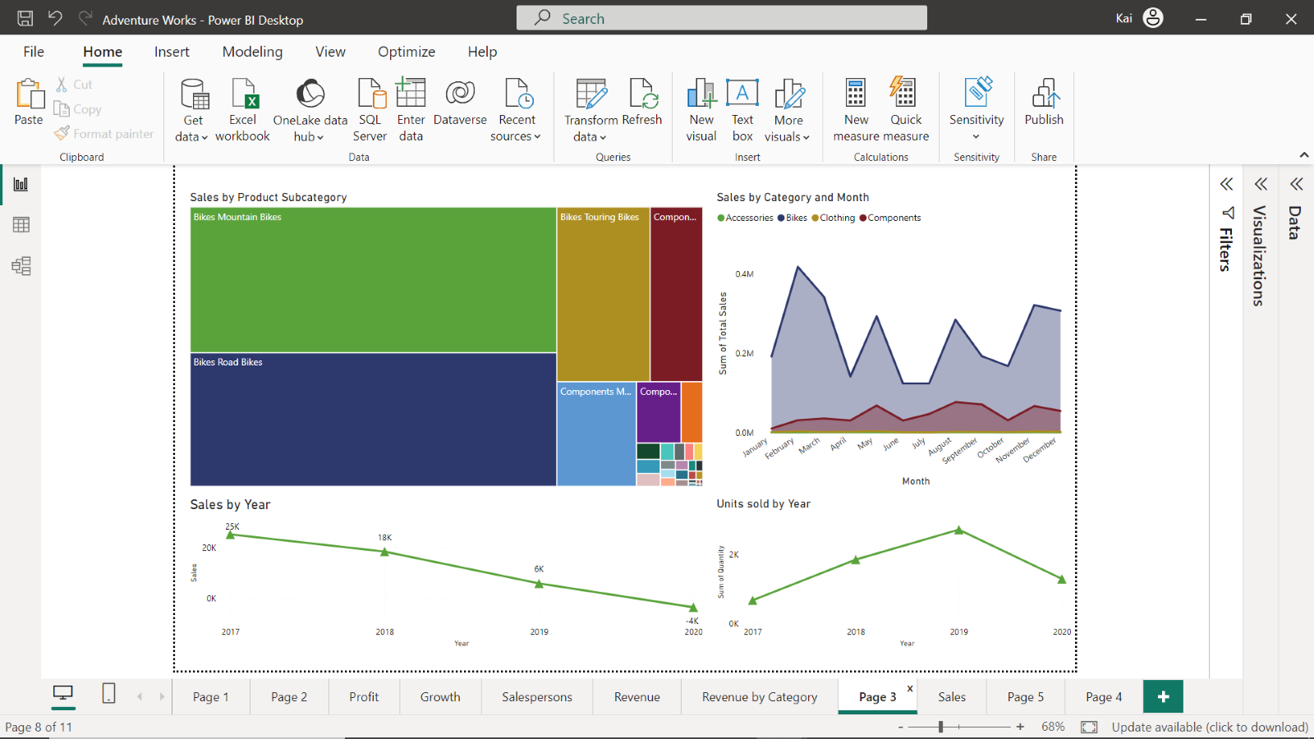
This dashboard presents how a wrong chart type will ruin your data story. The Sales by Product Subcategory treemap chart features too many colors without any data labels. The sales by year and units sold by year would be better presented as a bar or column chart with data labels, as there are only a few data points. With effective visuals, specifically charts effectively presenting data, users can clearly follow the story you are telling.

Example 3: Disconnected narrative
Another instance of poor storytelling dashboard is when the narrative is disconnected. An example of this is when the visual elements of the dashboard seem like a standalone story, lacking a connection that ties them together. Viewers are left struggling to grasp the story you are trying to tell.

The problem lies in having no clear goal, leading to an absence of narrative thread in the dashboard. A compelling data story means connecting the dots between visuals to form a coherent narrative. A story plot supported by a clear goal should guide your audience through the data, from problem identification to solution.
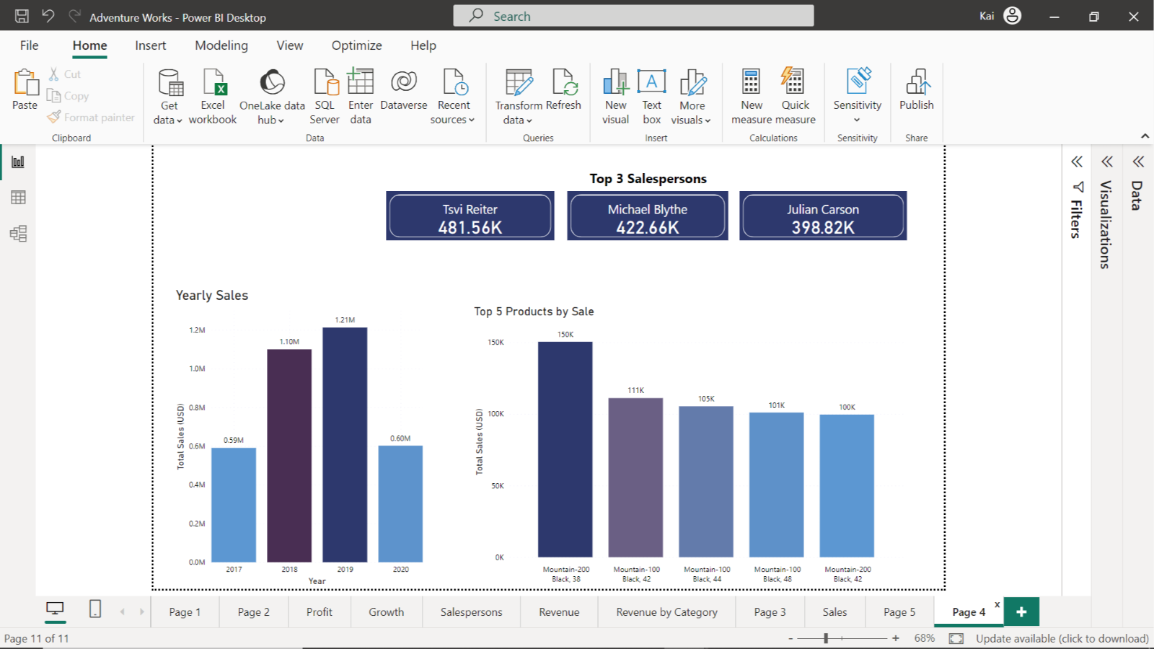
The dashboard looks visually appealing, but there is no clear story to what is being presented. Careful investigation of the report reveals that each visual element represents an independent data story. Card visuals represent the top three salespersons that should be part of the Salesperson dashboard. Yearly sales and top 5 products are related to sales and products dashboards, respectively.

Data visualization mistakes to avoid
- Including too many variables
The whole point of data visualization is to tell a story. Therefore, you need to include relevant information while excluding unnecessary details.

You should first identify the necessary variables you want to visualize which then direct you to choose a visual format. A pie chart, for example, that compares too many variables will make it difficult to comprehend the data and see the difference between values.

- Poor color choices
The proper use of colors allows viewers to understand the data you are trying to communicate. However, there can be challenges that arise when incorporating colors into your visuals.
Some typical issues that arise when using colors in your visualization include:
- Using too many colors, making it difficult for the viewer to quickly understand that they are looking at.
- Using colors with little contrast between one another.
- Not accounting for viewers who may have visual disabilities.
A typical example of color issues is with map visuals. Imagine a map visual of the United States of America, showing the sales amount for Adventure Works in every state. Colors are used to represent the different sales values per State.
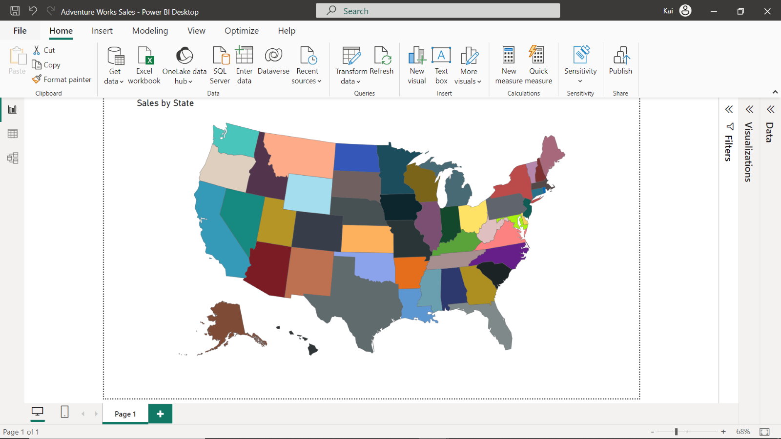
Instead of using three complimentary colors to indicate a high volume of sales, a moderate volume of sales, and a low volume of sales, a gradient has been used. The three shades are not distinguishable enough, and as the viewer observes the map there is no clarity.
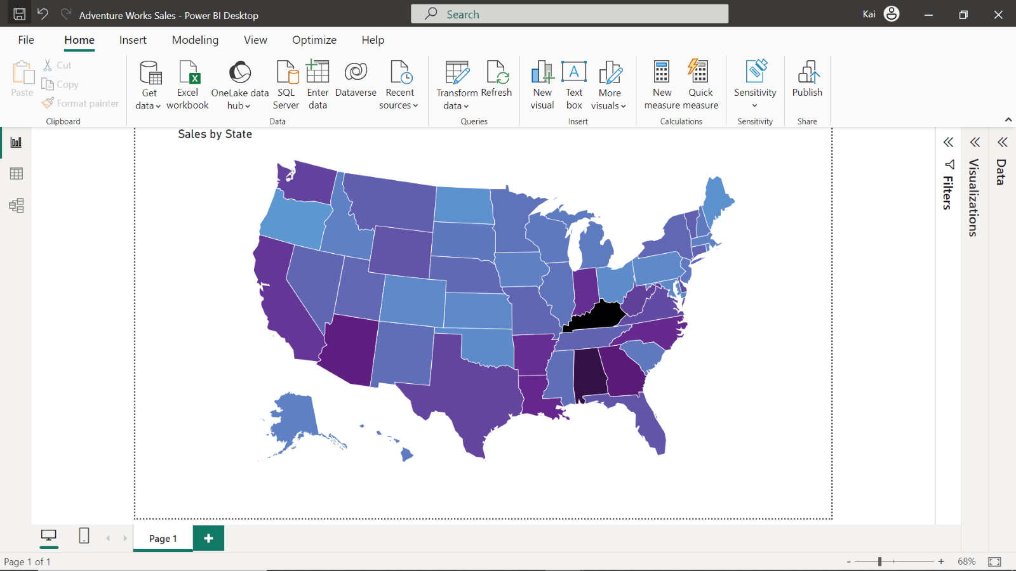
- Too many slicers
The use of too many slicers in your dashboard obscures the story behind your data. You need to make sure to design your report interactions in a proper way, and slicers are not always the best option, especially when they have a lot of elements.
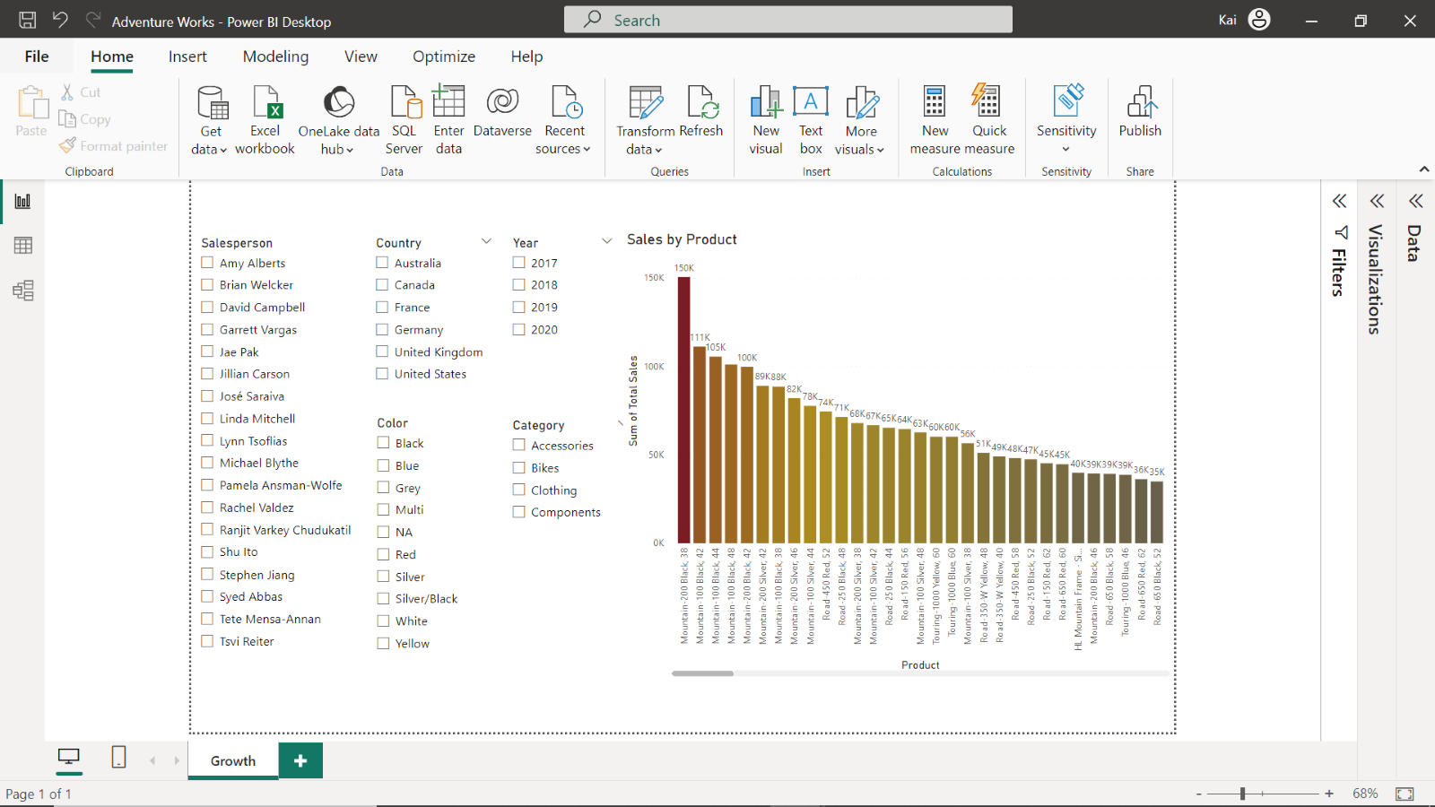
In the above dashboard, too many slicers make it difficult to comprehend the message of the story.
- Confusing page layout
Too many visual elements on your canvas means you will be unable to communicate clearly with the viewer.
Importing all the graphs and charts from your reports to a dashboard is an ineffective way to build your narrative. It brings clutter to your story and there is no way to know for certain what to pay attention to.
The standard rule to follow when designing dashboards is that people read from left to right and from top to bottom. This means you should always put your most important visualizations and most critical KPIs (Key Performance Indicators) to the left and top of the dashboard. You can then add details to the right and bottom of the report canvas to reinforce this message.

- Characteristics of Microsoft Power BI reports:
  - Reports support filtering and drill-through.
  - Reports are detailed and structured documents.
- True or False: In Power BI, you can optimize both reports and dashboards for mobile devices. True. Power BI allows you to create mobile-optimized versions of both reports and dashboards.
- When you select a tile on a dashboard (by clicking or tapping), the action executed is: The source report of the tile is opened on the screen. Clicking a dashboard tile typically takes you to the underlying report where that visual originated.
- The best way to collect feedback from peers on a dashboard in Microsoft Power BI service is:
- The best method to include an image gallery in your dashboard: You can add one representative image as a URL and share the entire gallery as an external URL of the image tile. This allows you to showcase one image while providing access to the full gallery.
- Live-streaming datasets you can use for report-building functionality, such as applying filters and slicers: Push dataset Push datasets allow for more traditional report-building features compared to other streaming options.
- Key components of data storytelling:
  - Narrative
  - Visualization
- The primary step you should take before designing a Marketing dashboard: Data exploration to identify which fields are needed to support the story. Understanding your data and identifying relevant metrics is crucial before starting to design your dashboard.
- To add your company logo to a dashboard when unable to pin it from your report: Publish the logo file online with an HTTPS connection and then add a URL to a media tile in the dashboard. This is a secure way to add external images to your dashboard.
- The guiding principle when selecting a chart or graph to visualize your data: Choose a chart that is appropriate for the data and the message. The chart type should be selected based on the nature of the data and the insight you're trying to convey

